$\overline{GRAPHICAL ABSTRACT}$

**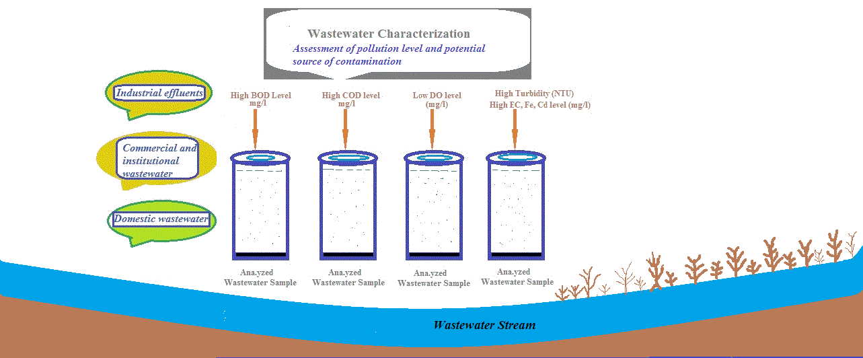**

$\overline{ABSTRACT}$

The research study was conducted to estimate the pollution level and the potential sources of contamination in the wastewater stream of Nalla Lai in the Rawalpindi region, Pakistan. A total of 19 wastewater samples were collected for the analyses of physicochemical parameters in the Clean laboratory, Islamabad. The experimental results of pH, temperature, sulfate (SO42-), chloride (Cl-), copper (Cu), manganese (Mn), lead (Pb), and zinc (Zn) values of the wastewater samples were within the standard limit range and values of NEQs, 1997 whereas dissolved oxygen (DO), electric conductivity (EC), iron (Fe) and cadmium (Cd) was detected above the recommended permissible limit value in many wastewater samples. Biological oxygen demand (BOD), chemical oxygen demand (COD), and turbidity results of all the wastewater samples were elevated from the standard limit values of National Environmental Quality Standards (NEQs, 1997) and Environmental Protection Agency, Ghana (EPA, Ghana). The potential sources of water contamination are the discharge of industrial effluents of the I-9 and I-10 sectors of Islamabad and commercial, institutional, and domestic effluents of Rawalpindi city. The above findings point out that the wastewater of Nalla Lai cannot discharge directly into any water body without proper treatment in the wastewater treatment plant.

$$\overline{HIGHLIGHTS}$$

* The research evaluates the pollution level in the wastewater stream of Nalla Lai, Rawalpindi
* Potential sources of contamination of the Nalla Lai stream are Industrial, commercial, and domestic effluents.
* Temperature, pH, SO42-, Cl-, Cu, Mn, Pb, and Zn results of Nalla Lai wastewater samples were detected within the permissible limit value of NEQs, 1997.
* EC, Fe, and Cd results of analyzed wastewater samples of Nalla Lai were beyond the standard limit value of EPA Ghana and NEQs 1997 in many wastewater samples.
* BOD, COD, and turbidity values of all the wastewater samples were beyond the standard limit value of NEQs, 1997 and EPA, Ghana.

**Keywords:** Nalla Lai, Wastewater, Rawalpindi, Pollution, National Environmental Quality Standards

$$\overline{1. INTRODUCTION}$$

Water is essential for sustaining life on our planet. The anthropogenic uses contaminate it and produce large amounts of wastewater. Wastewater discharge from sources like residential, commercial, storm-water runoff, agricultural, and industrial areas contains various kinds of pollutants (Sulieman 2010, Pescod 1992). The wastewater contains 99.9% liquid water and the rest are solids in the form of total suspended solids, total dissolved solids (fats, lignin, carbohydrates, soaps, synthetic detergents, and organic chemicals from the industrial processes), and inorganic solids (metals, bacteria and viruses) (Hassan et al. 2017). These pollutants harm human health and aquatic life which leads to poor health, environmental pollution, a less prosperous economy, and a low standard of life (Odjadjare 2010).

The disposal of municipal and industrial wastes in water bodies is a major problem concerning our environment which makes it fragile (Paul et al. 2012). At present, access to safe water is an important aspect of obtaining the goals of sustainable development (UNESCO 2015). The protection of freshwater resources is one of the most significant environmental issues of the 21st century (Daughton & Ternes 1999).

Worldwide approximately 80 % of the wastewater is not collected and treated (UNESCO 2012). Developed countries follow strict rules for the evacuation of pollutants whereas in developing countries such as African and Asian countries, the rules are not properly followed. As a result, most of the rivers are the final destination of these industrial effluents which hinders the effort to keep the environment clean from contamination. The effluents are not treated before final disposal to the waterway due to wastewater treatment costs, unconsciousness, and various other causes (Shaktibala & Bhagat, 2012; Valipour 2015; Ladwani et al. 2012).

Water quantity and properties also change with the physicochemical and biological pollution in water that affects the aquatic organisms living in that area (Kara & Comlekci 2004). Wastewater characterization is an important parameter in the engineering management of environmental quality to design, operate, collect, treat, and dispose waste (Muttamara 1996). Water quality studies reveal a variety of effluents and their sources (Meybeck 2002), Kannel et al. 2007) which harm the overall quality of water (Chang 2008; Chusov et al. 2014).

Therefore, it is crucial to know details about different physicochemical properties of wastewater such as pH, temperature, electric conductivity, dissolved oxygen, biological oxygen demand, chemical oxygen demand, total solids, total suspended and dissolved solids to evaluate the quality of wastewater (Karmoker et al. 2018).

The study investigated the pollution level of the Nalla Lai wastewater stream. The goal of the study is the characterization of wastewater stream that contains domestic, commercial, and industrial effluents that affect the ecosystem. This research opens several avenues for future research, which can aim to characterize the wastewater in more detail and depth to understand the anthropogenic input in water pollution.

$$\overline{2. MATERIAL AND METHODS}$$

**2.1 Description of Study Area**

Rawalpindi city is the fourth largest populous area and third largest metropolitan area of Pakistan. Rawalpindi is the city of Punjab province and borders the capital city of Islamabad, and the two cities are known as “twin cities” and have strong economic and social ties between these two cities (Atta et al. 2020). The city has a population of 2.09 million and the total area is 259 km2. The latitude and longitude of Rawalpindi city are 33.5984 ºN and 73.0441 ºE (Shahid et al. 2019). The hottest and coldest months are June and January and the highest and lowest temperature that was recorded is 48 °C and -3.9 °C (Sohail et al. 2020; Asghar et al. 2012; Khan et al. 2019).

The total length of Nalla Lai is about 30 km. Its catchment area is 239.8 Km2 out of which 73.6 Km2 is in Rawalpindi and 161.2 Km2 in Islamabad. It originates from the Margalla Hills Islamabad until the Soan River Rawalpindi. Nalla Lai contributes Soan River which is the tributary of the Indus River. It has six major tributaries, three originating in the foothills of Margalla, Islamabad, and the other three flows in the lower-lying city of Rawalpindi (Kamal 2004; Study 2004).

**2.2 Wastewater Sample Collection**

The wastewater samples of the Nalla Lai stream were collected by following the internationally recognized sampling procedure “Standard Methods for the Examination of Water and Wastewater” APHA (2012).

**Wastewater Sampling of Nalla Lai Stream**

A composite sampling technique (Raashid & Hussain 2014) was applied to collect wastewater samples from the Nalla Lai stream in October 2016. Polypropylene bottles were used to collect wastewater samples that were properly washed with hot tap water, detergent, water reagent and thricely rinsed with distilled water.

A total of nineteen samples were taken from the study area. Sample (1) was collected from the wastewater stream passing through the I-9 industrial sector of Islamabad whereas sample (2) was collected from the wastewater stream passing through the I-10 industrial sector of Islamabad. Both samples were collected near Kataria Bridge, Islamabad. Sample (3) was collected from the junction point of I-9 and I-10 industrial wastewater streams at the point of Kataria Bridge which is the starting point of the Nalla Lai wastewater stream. Samples 4-18 were collected from various distances along the Nalla Lai stream and sample (19) was collected from the endpoint of Nalla Lai before discharge of Nalla Lai wastewater into Soan River, Rawalpindi.

The wastewater samples were collected in a 1 Litre sampling container from each sampling point to analyze non-metals. Likewise, half-litre (500 ml) sampling containers were used to collect wastewater samples from each sampling point to detect heavy metals and preservatives (Nitric acid: HNO3) were added in each half-litre bottle to bring the pH of wastewater samples < 2 pH. The samples were labeled with sampling type, sample number, time and date of collection, source, and location.

**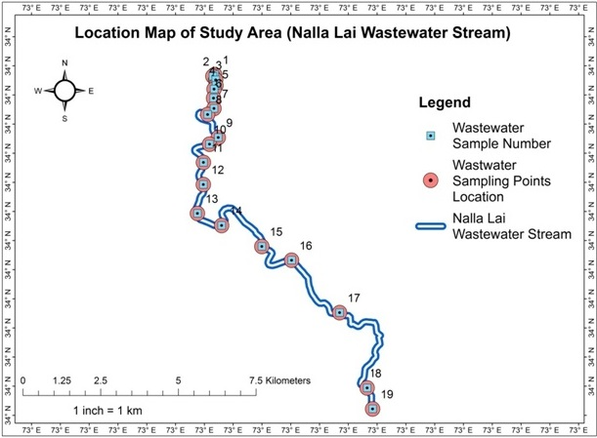**

**Figure 1 |** ArcGIS Map of Wastewater Sampling Points Location of Nalla Lai Stream (Study Area)

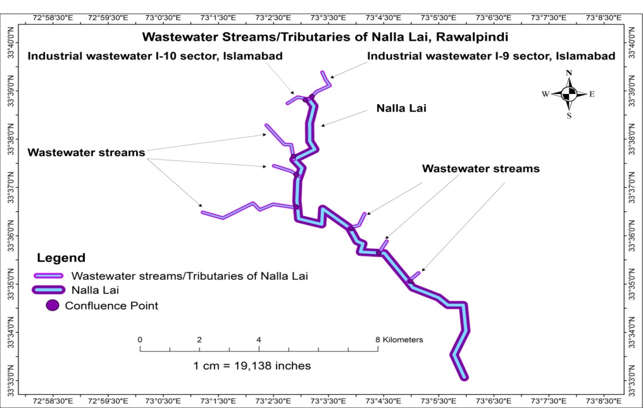

**Figure 2|** ArcGIS Map of Wastewater Streams/Tributaries of Nalla Lai in Rawalpindi

**Analytical Procedure**

**I) In situ or Field Analysis**

Some water quality parameters are tested on the spot in the field because water characteristics change with time and variation is noticed in results with time elapses due to which these parameters are analyzed in the field called Insitu or Field analysis. These parameters include pH (pH scale) which was tested with a pH Meter, Temperature (ºC) was checked with a Thermometer, Dissolved Oxygen (DO mg/L-1) was analyzed with a DO Meter, Electric Conductivity (EC µS/cm) and Total Dissolved Solids (TDS mg L-1) was analyzed with TDS Meter respectively.

**II) Physico-chemical Analysis**

The wastewater samples were shifted to the CLEAN laboratory of the Environmental Protection Agency, Islamabad, and kept at 4 ºC to protect the integrity of the samples. The turbidity of wastewater samples was analyzed by the instrument Water Analyzer. Sulfate (SO42-) was determined by UV/Visible Spectrometer, Chloride (Cl-) was determined by following the standard method for the examination of water and wastewater 22nd edition, part 4500 Cl-, Cadmium (Cd), Copper (Cu), Iron (Fe), Manganese (Mn), Lead (Pb), and Zinc (Zn) were determined by Atomic Absorption Spectrometer (AAS). Biological Oxygen Demand (BOD) was determined by following the standard methods for the examination of water and wastewater 22th edition, part 5210. Chemical Oxygen Demand (COD) was measured by following the standard methods for the examination of water and wastewater 22th edition, part 5220.

**III) Analysis of Experimental Data**

The experimental data was statistically analyzed and the maps of analyzed results were designed by using Microsoft Excel Environment, XLSTAT, and ArcGIS Pro software.

$\overline{3. RESULTS AND DISCUSSION}$

The results of physicochemical parameters of wastewater samples of the Nalla Lai stream and descriptive statistical analysis results of 19 wastewater samples along with the prescribed standards are mentioned in Table 1 and Table 2. The results of physicochemical parameters of wastewater samples of Nalla Lai revealed that turbidity was higher than the standard value of 75 NTU (EPA Ghana) in all wastewater samples. DO concentration was elevated from the standard value of 1.0 mg L-1 (EPA Ghana) in nine wastewater samples. EC was detected elevated from the standard value of 1500 µS/cm (EPA Ghana) in two wastewater samples. Iron concentration was detected beyond the standard value of 2 mg L-1 (NEQs, 1997) in 3 wastewater samples. Cadmium value exceeded the standard value of 0.1 mg L-1 (NEQs, 1997) in 5 wastewater samples. BOD and COD values of wastewater samples were beyond the permissible limit of 80 mg L-1 and 150 mg L-1 in all collected wastewater samples of Nalla Lai.

|  |  |  |  |  |  |  |  |  |  |  |  |  |  |  |  |
| --- | --- | --- | --- | --- | --- | --- | --- | --- | --- | --- | --- | --- | --- | --- | --- |
| **Table 1 |** Analyzed results of the Physico-chemical Parameter of the wastewater stream of Nalla Lai (n=19) | | | | | | | | | | | | | | | |
| **S.No** | **pH** | **Temp** | **Turbidity** | **DO** | **EC** | **SO42-** | **Cl-** | **Cd** | **Cu** | **Fe** | **Mn** | **Pb** | **Zn** | **BOD** | **COD** |
| 1 | 7.44 | 22 | 4610.20 | 0.94 | 1271 | 21.9 | 60 | 0.3 | 0.204 | 4.479 | 1.483 | 0.012 | 1.046 | 168 | 296 |
| 2 | 7.66 | 26 | 2725 | 2.05 | 1277 | 22.76 | 55.6 | 0.22 | BDL | 1.212 | 0.15 | 0.182 | 2.046 | 130 | 168 |
| 3 | 7.43 | 27 | 3113 | 1.03 | 1365 | 21.70 | 55.6 | 0.016 | BDL | 3.134 | 0.176 | BDL | 0.066 | 112 | 243 |
| 4 | 7.71 | 28 | 3689 | 0.33 | 1396 | 24.2 | 54.18 | BDL | 0.161 | 0.392 | 0.161 | BDL | 0.076 | 121 | 276 |
| 5 | 7.48 | 26 | 1940.24 | 0.74 | 1529 | 23.3 | 46.62 | BDL | 0.012 | BDL | 0.189 | 0.021 | 2.214 | 97 | 229 |
| 6 | 7.67 | 27 | 3635.84 | 0.20 | 1492 | 22.22 | 57.28 | BDL | 0.016 | BDL | 0.161 | BDL | 0.048 | 194 | 315 |
| 7 | 8.55 | 26 | 3645.65 | 1.24 | 1510 | 23.12 | 55.06 | BDL | BDL | 0.149 | 0.49 | BDL | 0.061 | 161 | 311 |
| 8 | 7.78 | 28 | 3459.74 | 1.25 | 1232 | 23.6 | 57.4 | 0.12 | BDL | BDL | 0.251 | BDL | 0.071 | 168 | 312 |
| 9 | 7.75 | 29 | 2313.49 | 0.26 | 1342 | 23.05 | 49.4 | BDL | BDL | 0.186 | 0.215 | BDL | 0.063 | 121 | 291 |
| 10 | 7.91 | 29 | 2111.69 | 1.04 | 1349 | 25.9 | 46.62 | 0.159 | 0.013 | 0.125 | 0.315 | BDL | 0.057 | 100 | 175 |
| 11 | 8.21 | 28 | 2543 | 1.65 | 1367 | 27.6 | 47.06 | 0.095 | BDL | 0.121 | 0.188 | BDL | 0.213 | 96 | 222 |
| 12 | 7.79 | 29 | 3130 | 0.63 | 1272 | 22.9 | 46.62 | 0.007 | BDL | 0.315 | 0.212 | 0.268 | 4.201 | 100 | 219 |
| 13 | 7.69 | 29 | 3343.74 | 0.35 | 1395 | 25.02 | 61.4 | 0.02 | BDL | BDL | 0.312 | BDL | 0.059 | 96 | 228 |
| 14 | 7.78 | 28 | 2981.84 | 0.81 | 1390 | 24.3 | 7.6 | 0.006 | 0.091 | BDL | 0.612 | BDL | 0.129 | 95 | 196 |
| 15 | 8.12 | 29 | 3399 | 1.14 | 1397 | 26.3 | 61.72 | 0.015 | BDL | 0.357 | 0.215 | 0.008 | 0.059 | 100 | 168 |
| 16 | 7.69 | 28 | 4215.73 | 0.69 | 1327 | 24.52 | 66.16 | BDL | 0.013 | 2.173 | 0.61 | BDL | 0.12 | 91 | 221 |
| 17 | 7.62 | 27 | 3386 | 0.26 | 1430 | 24.23 | 75.06 | 0.143 | BDL | 1.635 | 0.219 | BDL | 0.204 | 149 | 272 |
| 18 | 7.92 | 28 | 4155 | 2.80 | 1372 | 25.34 | 79.6 | 0.012 | BDL | 0.822 | 0.237 | BDL | 2.213 | 98 | 176 |
| 19 | 7.95 | 30 | 3490 | 2.67 | 1474 | 30.10 | 72.4 | 0.015 | BDL | 0.118 | 0.521 | BDL | 0.064 | 87 | 170 |

**Table 2 |** Descriptive statistical Analysis Results (n=19) of Nalla Lai wastewater Stream and comparison with Standards

|  |  |  |  |  |
| --- | --- | --- | --- | --- |
| **Variables** | **Unit** | **Maximum** | **Minimum** | **Average NEQs, 1997 EPA, Ghana** |
| pH |  | 8.55 | 7.43 | 7.8 6-10 |
| Temp | ºC | 30 | 22 | 27.58 40 |
| Turbidity | NTU | 4610.20 | 1940.24 | 3257.27 - 75 |
| DO | mgL-1 | 2.80 | 0.20 | 1.06 - 1.0 |
| EC | µS/cm | 1529 | 1232 | 1378.26 - 1500 |
| SO4-2 | mgL-1 | 30.10 | 21.70 | 24.32 600 |
| Cl- | mgL-1 | 79.6 | 7.6 | 55.55 1000 |
| Cd | mgL-1 | 0.3 | 0.006 | 0.09 0.1 |
| Cu | mgL-1 | 0.204 | 0.012 | 0.07 1.0 |
| Fe | mgL-1 | 4.48 | 0.12 | 1.09 2.0 |
| Mn | mgL-1 | 1.48 | 0.15 | 0.35 1.5 |
| Pb | mgL-1 | 0.268 | 0.008 | 0.10 0.5 |
| Zn | mgL-1 | 4.20 | 0.05 | 0.68 5.0 |
| BOD | mgL-1 | 194 | 87 | 120.21 80 |
| COD | mgL-1 | 315 | 168 | 236.21 150 |

**3.1 pH**

pH refers to the hydrogen ion concentration in water (Mandal 2014). It is the logarithmic scale for measuring the acidity or alkalinity of water (Amelot et al. 2018). Numerous external factors influence pH including temperature and aeration (Mandal 2014). pH value controls most of the chemical reactions in the water environment (Karmoker et al. 2018). Less than 6 pH scale in water shows a corrosiveness nature and a pH level elevated than 9 causes various metals to form precipitates of carbonates or hydroxides (Islam et al. 2016).

The National Environmental Quality Standards (NEQs, 1997) value of pH in wastewater is the range between 6-10. The average pH value of wastewater samples of the Nalla Lai stream was 7.8. The maximum and minimum pH values of wastewater samples were 8.55 and 7.43. pH values of all the analyzed wastewater samples along the Nalla Lai stream were within the range of NEQs, 1997. The results of pH values in wastewater samples and descriptive statistical analysis results along with the prescribed standards are mentioned in Table 1 and Table 2. pH values in each sampling point location along with the Nalla Lai wastewater stream are shown in Figure 3 of the ArcGIS map. The curve Fit line in Graph 1 shows the variation of pH values along with the Nalla Lai wastewater stream. Various wastewater streams containing domestic, institutional, and commercial effluents of Rawalpindi city are discharging their effluent directly into Nalla Lai at confluence points as shown in Figure 2. These wastewater streams may be alkaline in nature which has slightly elevated the pH level at various localities of the Nalla Lai wastewater stream. The analyzed values of pH were lower than the study results of Rouf et al. (2013) on tannery effluents in the Hazaribagh area of Dhaka city.

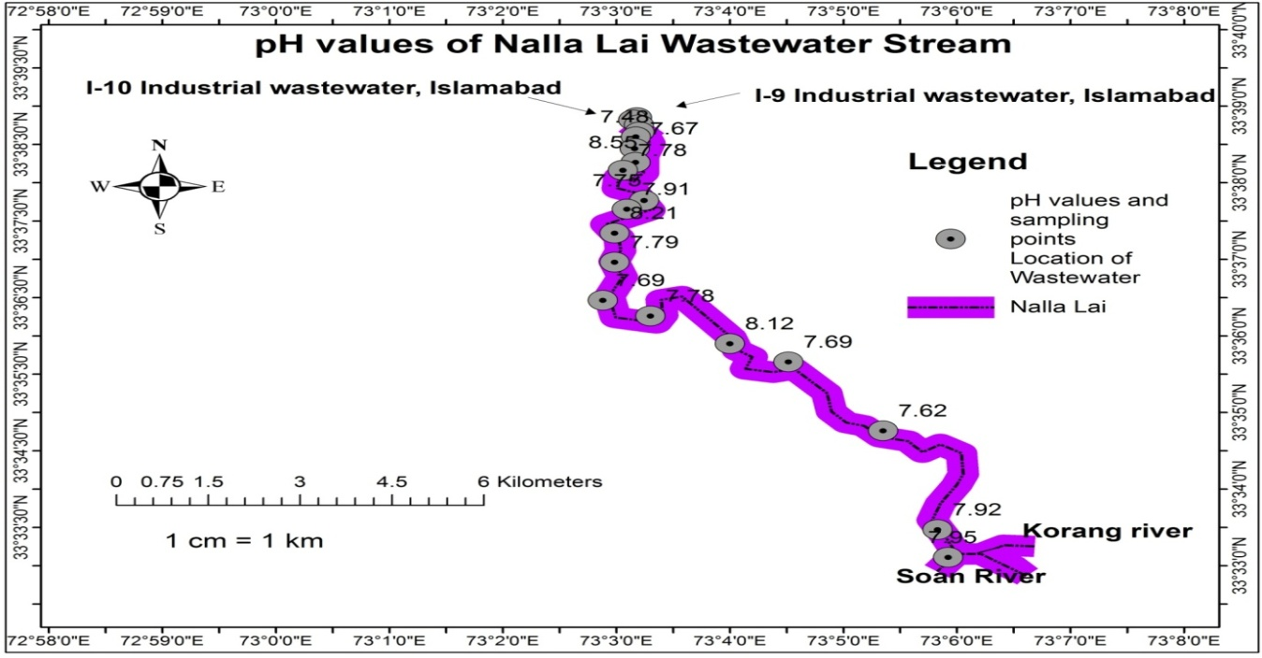

**Figure 3 | pH** values of wastewater samples along the Nalla Lai stream

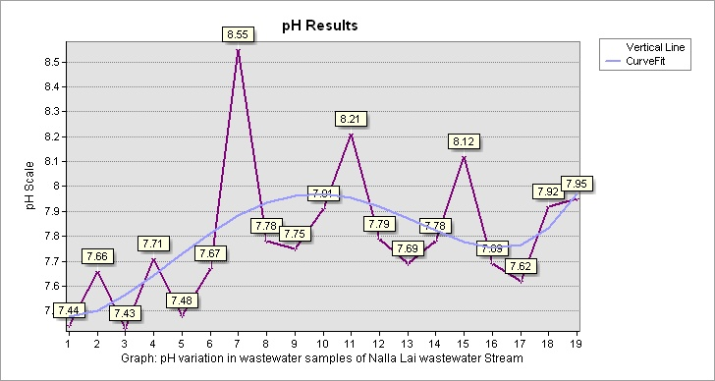

**Graph 1|** **pH** variation in wastewater samples of Nalla Lai stream

**3.2 Temperature**

Temperature is the key parameter of water because it affects the solubility of gases such as oxygen, aquatic life, and biological and chemical reaction rates. The mean annual temperature of water depends on geographic location. Unusual high temperature increases the growth of fungi and planktonic species whereas low temperature can limit the treatment of wastewater by increasing the treatment time (Muttamara 1996).

The National Environmental Quality Standards, 1997 (NEQs, 1997) value of temperature in wastewater is 40 ºC. The average value of temperature in the wastewater samples of Nalla Lai stream was 27.58 ºC. The maximum and minimum temperature values of wastewater samples were 30 ºC and 22 ºC. Temperature values of all the analyzed wastewater samples along the Nalla Lai stream were within the permissible limit of NEQs, 1997. The results of temperature values in wastewater samples and descriptive statistical analysis results along with set standards are mentioned in Table 1 and Table 2. Temperature values in each sampling point location along with the Nalla Lai wastewater stream are shown in Figure 4 of the ArcGIS map. The curve Fit line in Graph 2 represents the slide variation of temperature along the Nalla Lai wastewater stream due to the discharge of effluents from various wastewater tributaries along its way at the confluence points as shown in Figure 2. Temperature values of the wastewater stream of Nalla Lai were elevated from the study conducted by Kamberovic (2006) the minimum, maximum, and 5-year average values of wastewater stream within Bor copper mine, Serbia were lower than the temperature results of the wastewater stream of Nalla Lai.

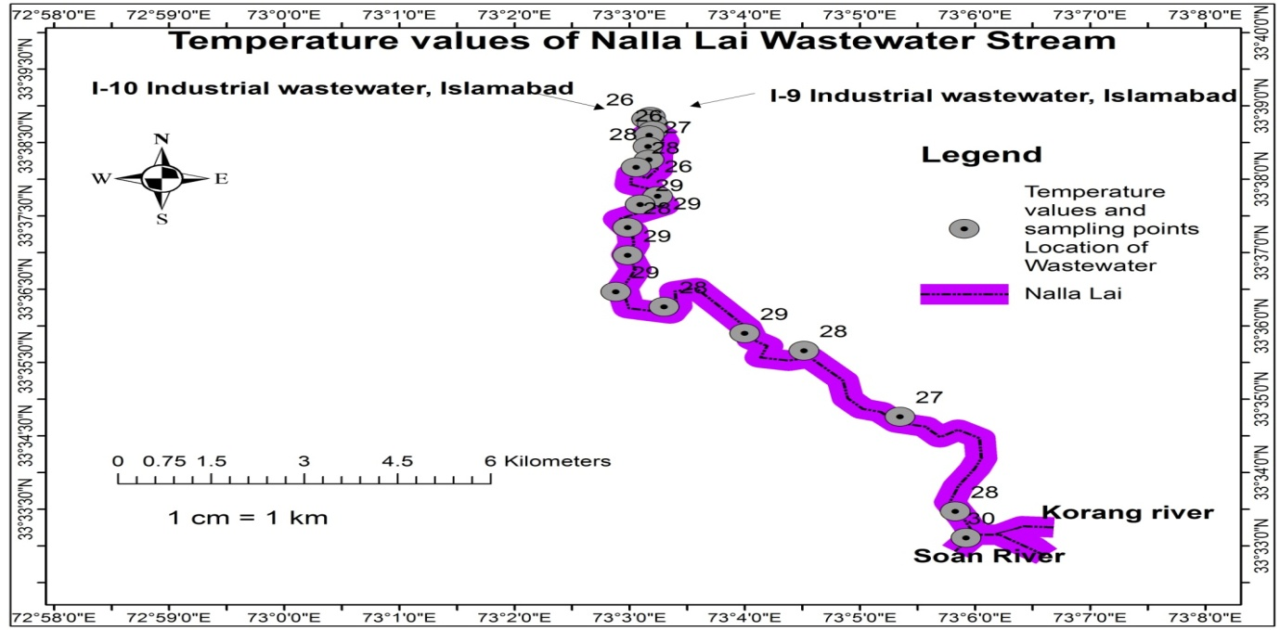

**Figure 4|** **Temperature** values of wastewater samples along the Nalla Lai stream

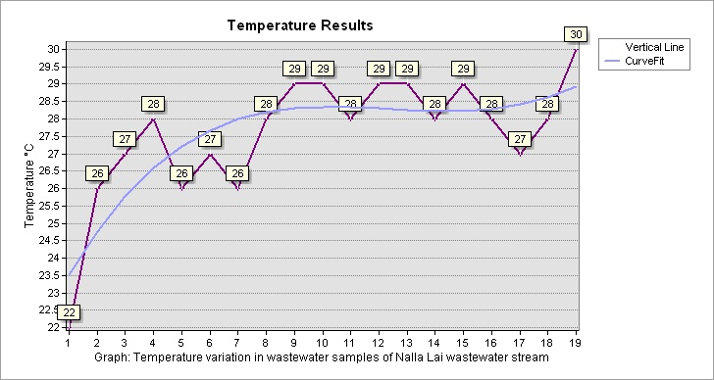

**Graph 2|** **Temperature** variation in wastewater samples of Nalla Lai stream

**3.3 Turbidity**

Turbidity is the existence of suspended particles in the water which inhabit the passage of light through it (Mandal 2014). Turbidity is measured by Nephelometric turbidity units (NTU) or Jackson turbidity units (JTS) It is the cloudiness of the fluid caused by suspended sediments like silt, sand, mud, organic and inorganic matter, bacteria, and other microorganisms and chemical precipitates (Mohammed 2015; Mullins et al. 2018).

The EPA Ghana standard value of turbidity in wastewater is 75 NTU (Owusu-Ansah et al. 2015). The average value of turbidity in the wastewater samples of Nalla Lai stream was 3257.27 NTU. The maximum and minimum turbidity values of wastewater samples were 4610.20 NTU and 1940.24 NTU. Turbidity was detected elevated from the standard value of EPA Ghana in all wastewater samples. The results of turbidity values in wastewater samples and descriptive statistical analysis results along with set standards are mentioned in Table 1 and Table 2. Turbidity values in each sampling point location along with the Nalla Lai wastewater stream are shown in Figure 5 of the ArcGIS map. The curve Fit line in Graph 3 represents the variation of turbidity along the Nalla Lai wastewater stream. The turbidity level decreased at the midpoint of Nalla Lai due to the fact the less turbid wastewater streams are mixing with Nalla Lai at the confluence points as shown in Figure 2 which diluted the high turbid wastewater and decreased the wastewater turbidity level. Turbidity results were elevated from the study results conducted by Haider & Ali (2012) when monitoring the diurnal variation in wastewater at the main outfall disposal station in Lahore, Pakistan.

**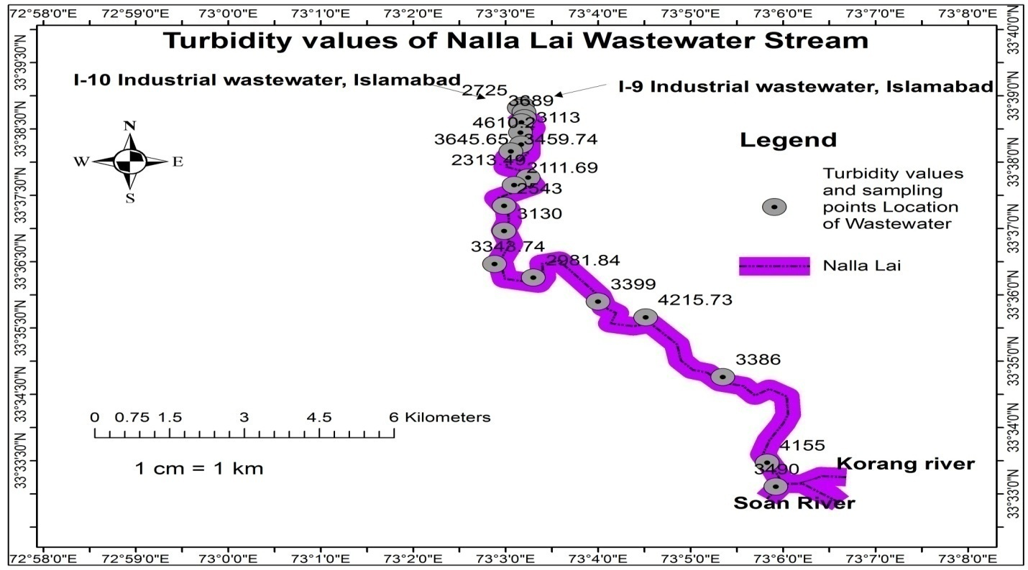**

**Figure 5|** **Turbidity** values of wastewater along the Nalla Lai stream

**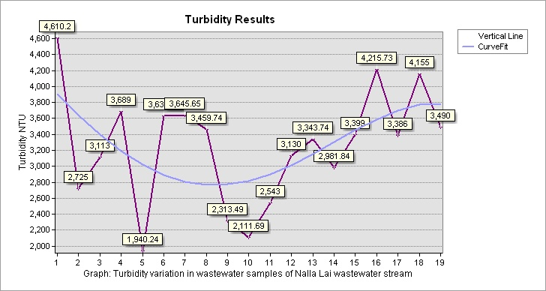**

**Graph 3| Turbidity** variation in wastewater samples of Nalla Lai stream

**3.4 Dissolved Oxygen**

Dissolved oxygen in water is vital for aquatic organisms. Dissolved oxygen concentration changes with temperature, salinity, and air pressure. The higher the temperature and salts, the lower the dissolved oxygen in water whereas the higher the air pressure, the higher the dissolved oxygen concentration in water. Oxygen dissolves in water from the atmosphere or it may be the byproduct of photosynthesis of aquatic plants. It provides significant information about biological and biochemical actions in water. It is an important parameter for measure contamination levels and water quality (Wetzel & Likens, 2000; Tai et al. 2012).

The EPA Ghana Standard value of DO in wastewater is 1.0 mg L-1 (Owusu-Ansah et al. 2015). The average value of dissolved oxygen in the wastewater samples of Nalla Lai stream was 1.06 mg L-1. The maximum and minimum dissolved oxygen values of wastewater samples were 2.80 mg L-1 and 0.20 mg L-1. The results revealed that DO was detected elevated from the standard value of EPA Ghana in nine wastewater samples of Nalla Lai. The results of dissolved oxygen values in wastewater samples and descriptive statistical analysis results along with the prescribed standards are mentioned in Table 1 and Table 2. DO values in each sampling point location along with the Nalla Lai wastewater stream are shown in Figure 6 of the ArcGIS map. The curve Fit line in Graph 4 shows that dissolved oxygen level increased in the last two wastewater samples Nalla Lai before discharge into Soan River. This variation might be because no additional wastewater tributaries added to Nalla Lai in this section and also when water moves and covers a certain distance it dissolves more oxygen from the atmosphere. Low DO values of wastewater samples of Nalla Lai were detected as compared to the study conducted by Jeremias (2010) where the discharge of municipal sewage enters the Bons Sinais estuary.

**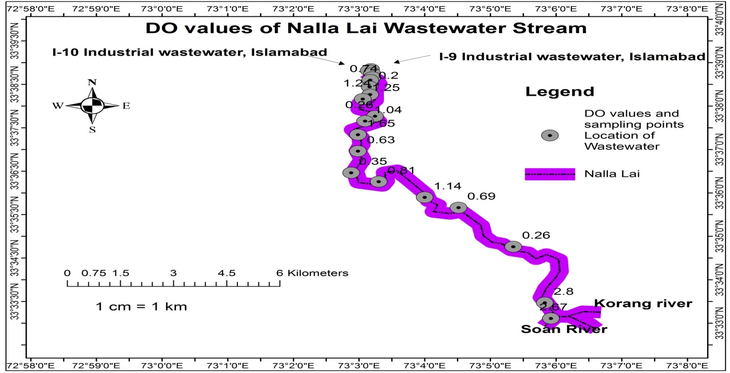**

**Figure 6| Dissolved Oxygen** values of wastewater along the Nalla Lai stream

**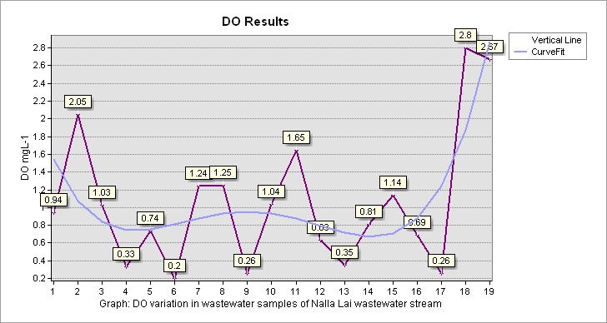**

**Graph 4|** **Dissolved Oxygen** variation in wastewater samples of Nalla Lai stream

**3.5 Electric Conductivity**

Electric conductivity measures the capacity of water to conduct an electric current. EC depends on the sum of anions and cations. Most of the salts in water exist in the form of ions which enable water to conduct current. EC serves as a good and quick measure of total dissolved solids in water and an excellent indicator of TDS. EC also determines the concentration of metal ions in a solution. EC is often used to measure the salinity of water and wastewater (Werkneh et al. 2015; Prieto et al. 2001; Mohsin et al. 2013).

The EPA Ghana standard value of electric conductivity in wastewater is 1500 µS/cm (Owusu-Ansah et al. 2015). The average value of electric conductivity in the wastewater samples of Nalla Lai stream was 1378.26 µS/cm. The maximum and minimum electric conductivity values of wastewater samples were 1529 µS/cm and 1232 µS/cm. EC was detected in elevated concentration from the standard value of EPA Ghana in two wastewater samples of Nalla Lai. The results of electric conductivity values in wastewater samples and descriptive statistical analysis results are mentioned in Table 1 and Table 2. EC values in each sampling point location along with the Nalla Lai wastewater stream are shown in Figure 7 of the ArcGIS map. The curve Fit line in Graph 5 shows that EC values fluctuate at certain points due to the discharge of wastewater effluents into Nalla Lai at various confluence areas as shown in Figure 2. EC results of Nalla Lai wastewater samples were lower than the study conducted by Maqsood et al. (2023) on wastewater characterization of Chiniot Drain, Pakistan.

**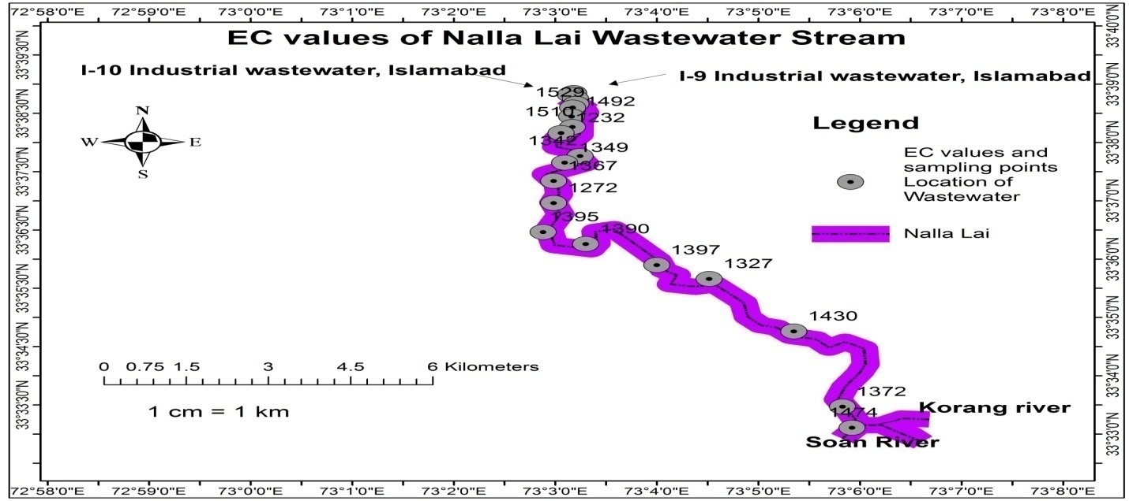**

**Figure 7|** **Electric Conductivity** values of wastewater along the Nalla Lai stream

**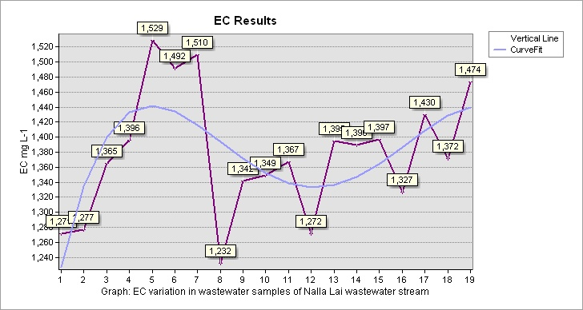**

**Graph 5|** **Electric Conductivity** variation in wastewater samples of Nalla Lai stream

**3.6 Sulfate**

Sulfur occurs in nature in three stable oxidation states i.e. 0 (native sulfur), -2 (sulfide), and +6 (sulfate) (Bowell et al. 2004). Sulfate is a common anion that dissolves in water from both natural and anthropogenic sources. Natural sources include the oxidation of sulfide minerals e.g. pyrite, sulfate minerals e.g. gypsum, etc. Anthropogenic sources include industrial wastewater, sewage infiltration, fertilizers, detergents, etc. (Wang & Zhang 2019).

The National Environmental Quality Standards, 1997 (NEQs, 1997) value of sulfate in wastewater is 600 mg L-1. The average value of sulfate in the wastewater samples of Nalla Lai stream was 24.32 mg L-1. The maximum and minimum sulfate values of wastewater samples were 30.10 mg L-1 and 21.70 mg L-1. Sulfate values of all analyzed wastewater samples along with the Nalla Lai stream were within the permissible limit of NEQs, 1997. The results of sulfate values in wastewater samples and descriptive statistical analysis results along with the set standards are mentioned in Table 1 and Table 2. Sulfate values in each sampling point location along with the Nalla Lai wastewater stream are shown in Figure 8 of the ArcGIS map. The curve Fit line in Graph 6 indicates that sulfate is slightly in high concentration at certain points as compared to other points. It might be due to wastewater streams that discharge their effluents into the Nalla Lai wastewater at different confluence sites of Rawalpindi as shown in Figure 2.

**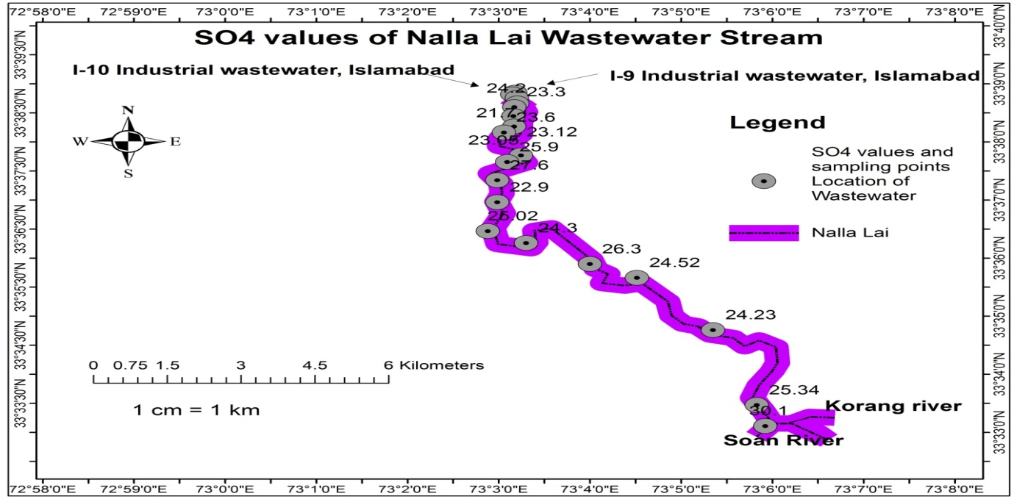**

**Figure 8|** **Sulfate** values of wastewater along the Nalla Lai stream

**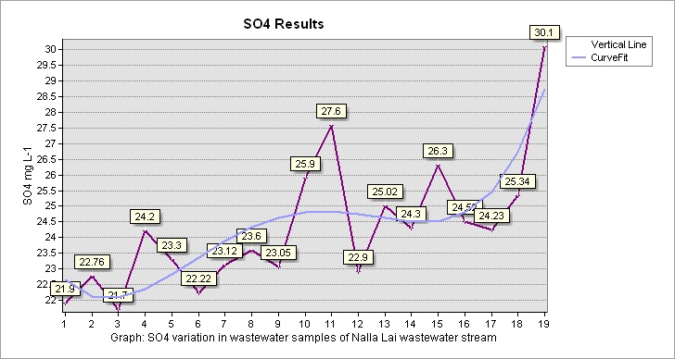**

**Graph 6|** **Sulfate** variation in wastewater samples of Nalla Lai stream

**3.7 Chloride**

Chloride is one of the important inorganic anions in water. Chloride exists in nature in the form of sodium chloride (NaCl), calcium chloride (CaCl2), and potassium chloride (KCl). Chloride leaches from a variety of rocks into water and soil through the weathering process. Chloride anion presents in water as a result of the dissociation of sodium chloride and calcium chloride. They give a salty taste to water. Chloride is formed when the element chlorine gains or loses electrons or when hydrogen chloride is dissolved in water. The anthropogenic sources of Chloride in water are inorganic fertilizers, landfills, animal feed, septic tank effluents, industrial effluents, etc (Venkatesan & Swaminathan 2009; Pal & Chakraborty 2017).

The National Environmental Quality Standards, 1997 (NEQs, 1997) value of chloride in wastewater is 1000 mg L-1. The average value of chloride in wastewater samples of Nalla Lai was 55.55 mg L-1. The maximum and minimum chloride values of wastewater samples were 79.6 mg L-1 and 7.6 mg L-1. Chloride values of all the analyzed wastewater samples along with the Nalla Lai stream were within the permissible limit of NEQs, 1997. The results of chloride values in wastewater samples and descriptive statistical analysis results along with the recommended standards are mentioned in Table 1 and Table 2. Chloride values in each sampling point location along with the Nalla Lai wastewater stream are shown in Figure 9 of the ArcGIS map. The curve Fit line in Graph 7 shows that chloride is comparatively detected in higher concentration in the last five samples of Nalla Lai before discharge into Soan River.

**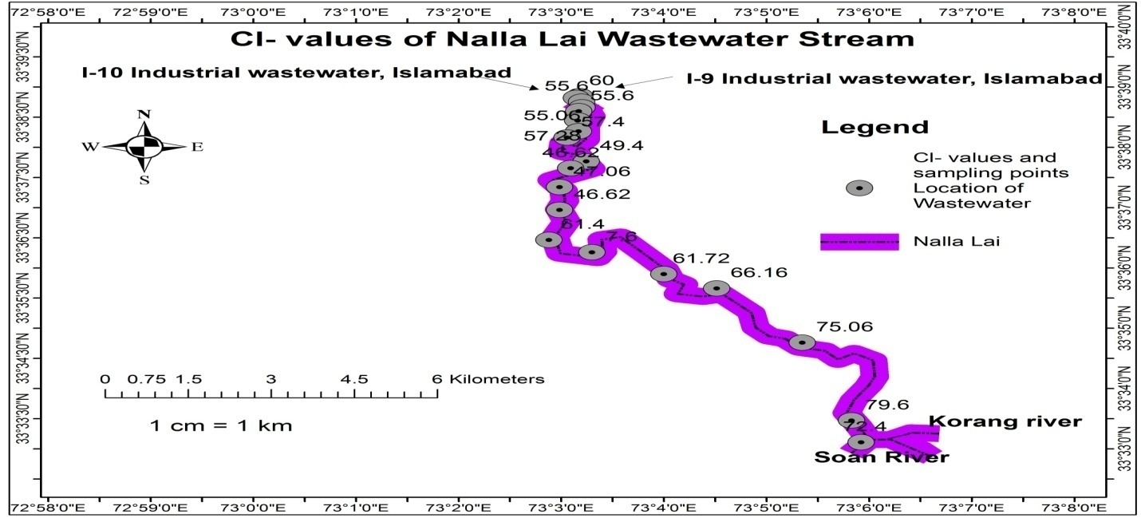**

**Figure 9|** **Chloride** values of wastewater along the Nalla Lai stream

**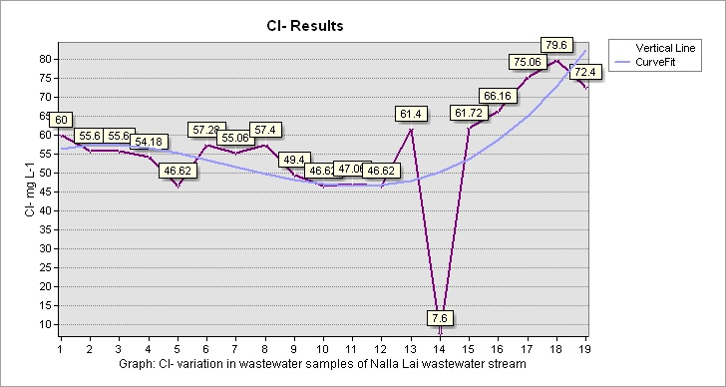**

**Graph 7|** **Chloride** variation in wastewater samples of Nalla Lai stream

**3.8 Cadmium**

Cadmium is a heavy metal that occurs naturally with lead and zinc in sulfide ores. The anthropogenic sources of cadmium in the environment are the burning of fossil fuel and cadmium-based products, tobacco, fertilizers, agricultural sludge, municipal wastewater, sewage discharges, etc. (WHO 2004; dos Santos et al. 2006; Nai et al 2015).Cadmium exists in water mainly from the erosion of natural deposits but can also be present in water due to runoff, discharge from waste batteries, metal refineries, and paint (Ahmed & Mokhtar 2020).

The National Environmental Quality Standards, 1997 (NEQs, 1997) value of cadmium in wastewater is 0.1 mg L-1. The average value of cadmium in wastewater samples of Nalla Lai was 0.09 mg L-1. The maximum and minimum cadmium values of wastewater samples were 0.3 mg L-1 and 0.006 mg L-1. Cadmium value in 5 wastewater samples was elevated from the standard value of NEQs, 1997. Higher concentrations were detected in wastewater samples collected from the wastewater streams carrying industrial effluents of I-9 and I-10 industrial sectors, Islamabad. The results of cadmium values in wastewater samples and descriptive statistical analysis results along with the set standards are mentioned in Table 1 and Table 2. Cadmium values in each sampling point location along with the Nalla Lai wastewater stream are shown in Figure 10 of the ArcGIS map. The curve Fit line in Graph 8 shows that cadmium concentration was detected in elevated concentration from the standard value in the wastewater samples of industrial discharges of Islamabad as well as other localities of the Nalla Lai stream. The concentration of cadmium was detected in BDL (Below the detection limit) at various points of Nalla Lai. It may be due to the wastewater tributaries of Rawalpindi that are discharging into Nalla Lia at various confluence localities as shown in Figure 2. These tributaries may be alkaline causing cadmium to form precipitates of carbonates and hydroxide and settle at the bottom of Nalla Lai and did not detect in analyzed wastewater samples. As stated by Islam et al. (2016) water pH level elevated than 9 causes various metals to form precipitates of carbonates or hydroxides.

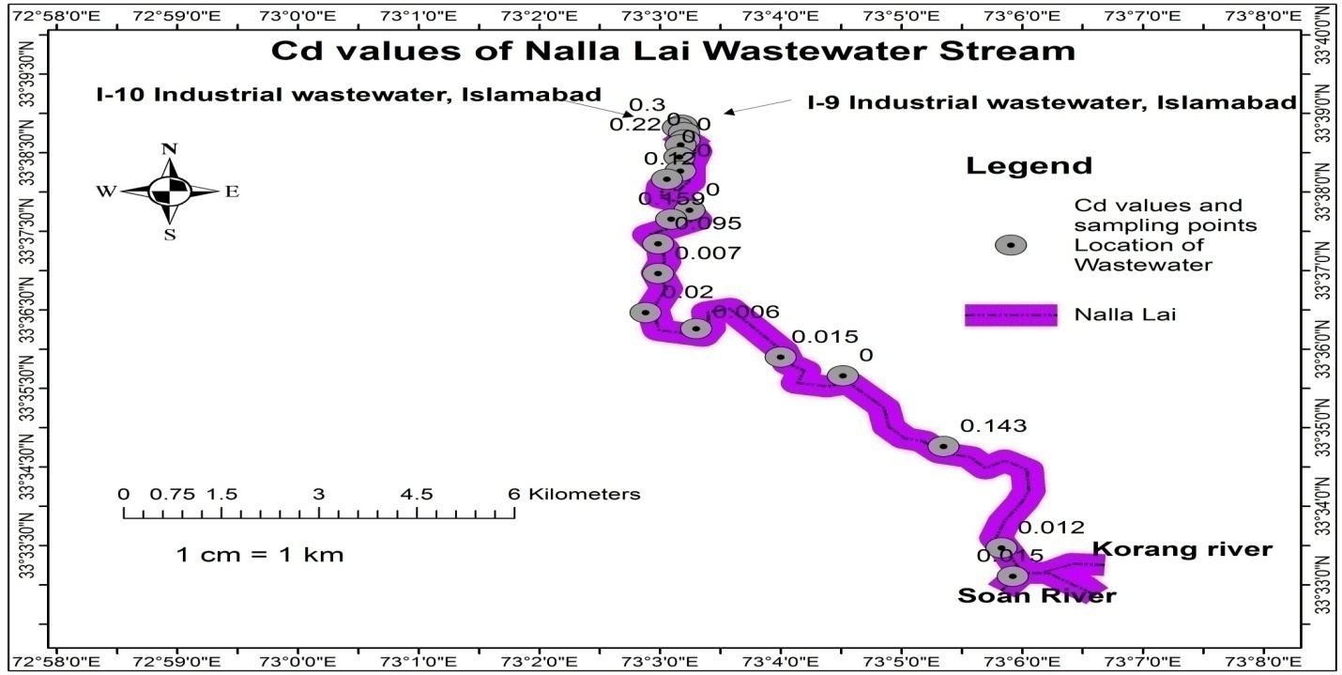

**Figure 10|** **Cadmium** values of wastewater along the Nalla Lai stream

**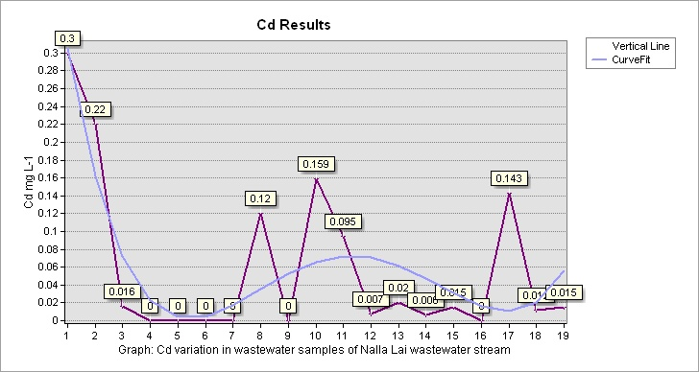**

**Graph 8|** **Cadmium** variation in wastewater samples of Nalla Lai stream

**3.9 Copper**

Copper occurs in chalophile/ chalcopyrite deposits along with cadmium (Cd), lead (Pb), and zinc (Zn) (Shrivastava 2009). It is a transition metal and exists in four oxidation states i.e. Cu (0), Cu (I), Cu (II), Cu (III), and, Cu (IV). Copper is a natural component of soil and is transported into water bodies through runoff due to weathering or disturbed soil. The anthropogenic sources of copper in water are corrosion of copper pipes, smelting, copper roofs, and car breaks may also be added through stormwater into wastewater and sewage sludge (Dietrich et al 2004; Shrivastava 2009; Georgopoulos et al, 2001; Fjallborg & Dave 2023).

The National Environmental Quality Standards, 1997 (NEQs, 1997) value of copper in wastewater is 1.0 mg L-1. The average value of copper in wastewater samples of Nalla Lai was 0.07 mg L-1. The maximum and minimum copper values of wastewater samples were 0.204 mg L-1 and 0.012 mg L-1. Copper values of all the analyzed wastewater samples along the Nalla Lai stream were within the permissible limit of NEQs, 1997. The results of copper values in wastewater samples and descriptive statistical analysis results along with set standards are mentioned in Table 1 and Table 2. Copper values in each sampling point location along with the Nalla Lai wastewater stream are shown in Figure 11 of the ArcGIS map. The curve Fit line in Graph 9 shows that copper was detected slightly in higher concentration at the starting point of Nalla Lai as compared to other points. This is because these wastewater samples were collected from the industrial discharges of Islamabad that were draining into Nalla Lai at the confluence locality as shown in Figure 2.

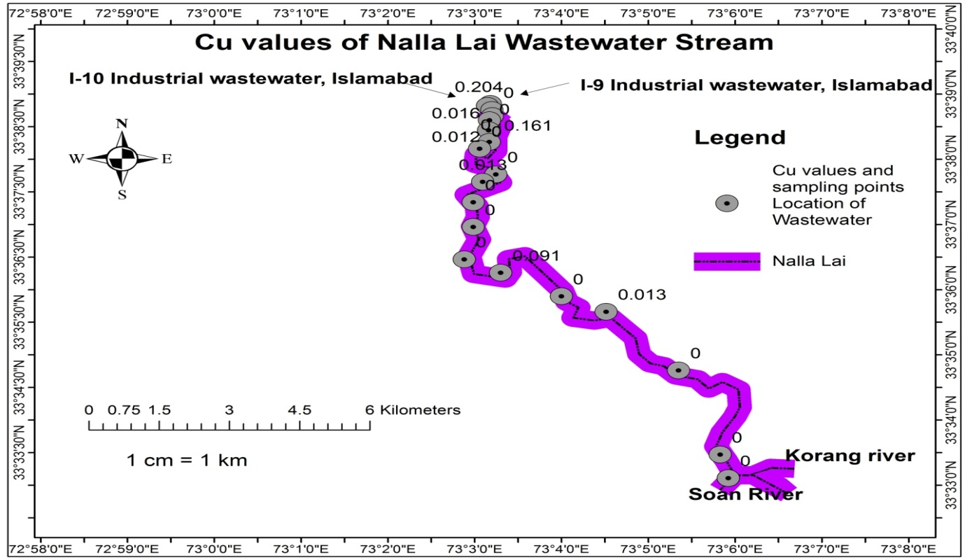

**Figure 11|** **Copper** values of wastewater along the Nalla Lai stream

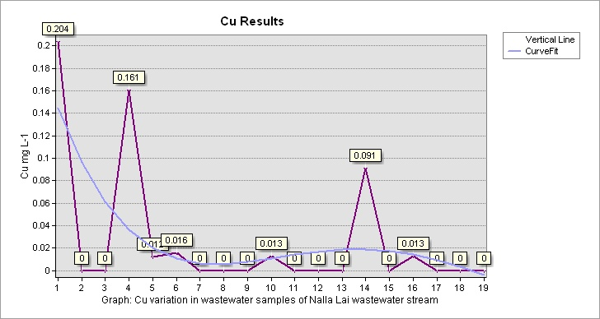

**Graph 9|** **Copper** variation in wastewater samples of Nalla Lai stream

**3.10 Iron**

Iron is a metal that occupies 5 percent of the earth’s crust. Iron-containing ores include magnetite, hematite, and taconite. Ferrous++ and Ferric+++ are the primary forms of iron in the aquatic environment. Rainwater dissolves minerals that contain iron when percolates through soil and rocks and makes a solution that recharges surface water and aquifers. Anthropogenic sources of iron contamination in water include corrosion of iron pipes which deteriorates it through the oxidation reaction at the surface of the pipes and affects water quality. The waste effluents discharged from iron and steel industries are also the major source of iron contamination in water (Colter & Mahler 2006; Kumar & Puri 2012; Sarin et al. 2004; Benson et al. 2012; Sarkar & Shekhar 2018).

The National Environmental Quality Standards, 1997 (NEQs, 1997) value of Iron in wastewater is 2.0 mg L-1. The average value of Iron in wastewater samples of Nalla Lai was 1.09 mg L-1. The maximum and minimum iron values of wastewater samples were 4.48 mg L-1 and 0.12 mg L-1. Iron concentration was detected elevated from the standard value of NEQs, 1997 in 3 wastewater samples. The results of iron values in wastewater samples and descriptive statistical analysis results along with set standards are mentioned in Table 1 and Table 2. Iron values in each sampling point location along with the Nalla Lai wastewater stream are shown in Figure 12 of the ArcGIS map. The curve Fit line in Graph 10 shows the higher concentration of iron in the starting two wastewater samples that were collected from the wastewater streams carrying effluents of the I-9 and I-10 industrial sectors of Islamabad. The third sample was collected from the confluence point of I-9 and I-10 wastewater streams which is the starting point of Nalla Lai in Rawalpindi. The iron concentration in sample 3 was also elevated from the standard value of NEQS, 1997. Iron concentration was detected in BDL (below the detection limit) at various localities of the Nalla Lai wastewater stream. This might be due to wastewater streams discharging into Nalla Lai at various confluence points in Rawalpindi as shown in Figure 2. The wastewater stream may be alkaline causing the iron to form precipitates of carbonate and hydroxide and settle at the base of wastewater stream of the Nalla Lai and was not detected in analyzed samples. As stated by Islam et al. (2016) water pH level elevated than 9 causes various metals to form precipitates of carbonates or hydroxides.

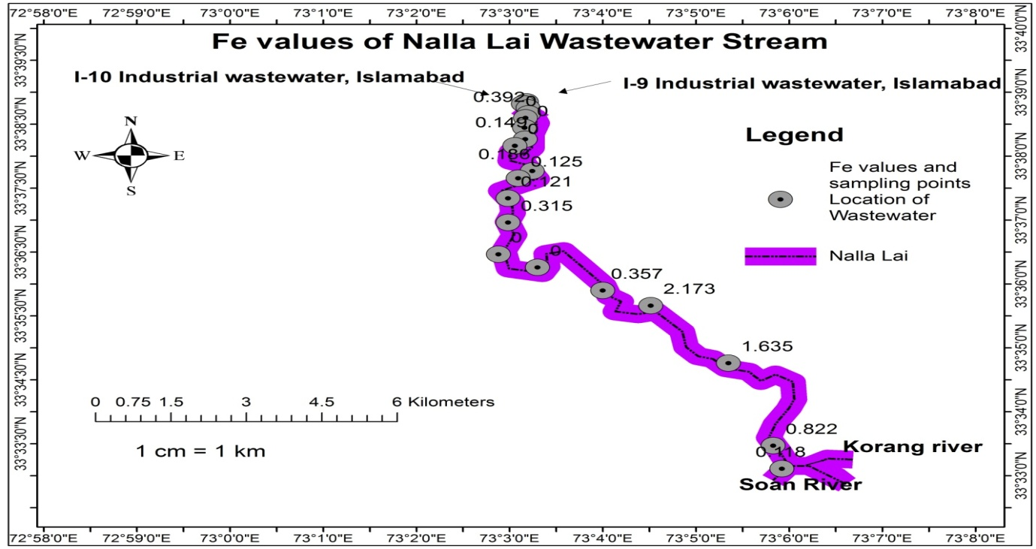

**Figure 12|** **Iron** values of wastewater along the Nalla Lai stream

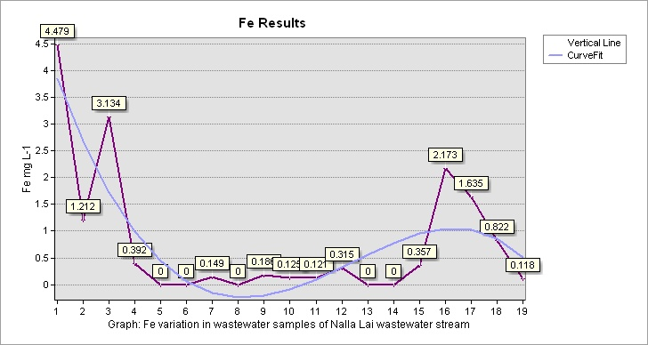

**Graph 10| Iron** variation in wastewater samples of Nalla Lai stream

**3.11 Manganese**

Manganese is a metal that exists naturally in surface water as a result of weathering and solubilizing manganese from bedrock and soil. It commonly occurs as Mn (II) and Mn (III) in the environment. The elemental manganese does not exist naturally rather it is found in mineral forms such as manganese dioxide, manganese silicate, and manganese carbonate. The anthropogenic sources of manganese in water include mining, steel production, battery production, chemical production, etc. (Das et al. 2014; Remucal & Vogel 2014; Patil et al. 2016; Li et al. 2014; Ljung & Vahter 2007).

The National Environmental Quality Standards, 1997 (NEQs, 1997) value of Manganese in wastewater is 1.5 mg L-1. The average value of Manganese in wastewater samples of the Nalla Lai was 0.35 mg L-1. The maximum and minimum manganese values of wastewater samples were 1.48 mg L-1 and 0.15 mg L-1. Manganese values of all the analyzed wastewater samples along the Nalla Lai stream were within the range of NEQs, 1997. The results of manganese values in wastewater samples and descriptive statistical analysis results along with set standards are mentioned in Table 1 and Table 2. Manganese values in each sampling point location along with the Nalla Lai wastewater stream are shown in Figure 13 of the ArcGIS map. The curve Fit line in Graph 11 shows that manganese was detected slightly in higher concentration as compared to other points in the first two wastewater samples that were collected from the wastewater streams carrying the effluents of the industrial locality of Islamabad and discharge into Nalla Lai at the confluence area as shown in Figure 2.

**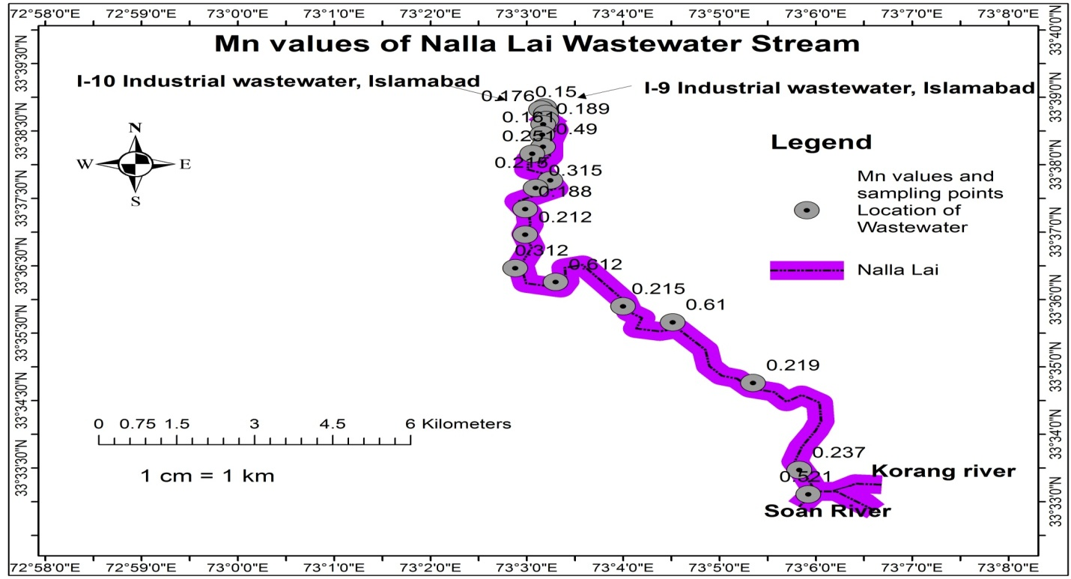**

**Figure 13|** **Manganese** values of wastewater along the Nalla Lai stream

**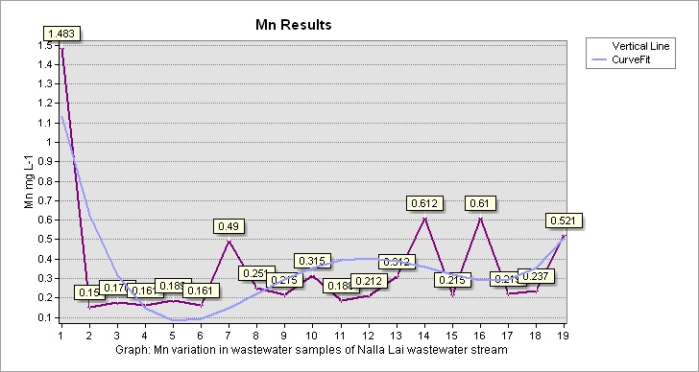**

**Graph 11|** **Manganese** variation in wastewater samples of Nalla Lai stream

**3.12 Lead**

Lead is a kind of heavy metal that is dangerous and a key environmental pollutant (Hu et al. 2010). Lead exists in ores, generally with zinc, copper, and silver. Lead minerals include galena (lead sulfide), lead carbonate, and lead sulfate. Natural pollution occurs from forest fires and volcanic explosions. Anthropogenic sources of lead concentration in water include lead piping. Lead is also found in polyvinyl chloride (PVC) pipes that can leach due to corrosion and contaminate water. Other sources of lead concentration in water include mining and smelting activities, and industrial manufacturing (WHO, 2003; Levallois et al. 2018; Zhang et al. 2015)**.**

The National Environmental Quality Standards, 1997 (NEQs, 1997 value of lead in wastewater is 0.5 mg L-1. The average value of lead in wastewater samples of Nalla Lai was 0.10 mg L-1. The maximum and minimum lead values of wastewater samples were 0.268 mg L-1 and 0.008 mg L-1. Lead concentrations were detected in only 5 wastewater samples in a very low concentration. Lead values of the analyzed wastewater samples along the Nalla Lai stream were within the range of NEQs, 1997. The results of lead values in wastewater samples and descriptive statistical analysis results along with the set standards are mentioned in Table 1 and Table 2. Lead values in each sampling point location along with the Nalla Lai wastewater stream are shown in Figure 14 of the ArcGIS map. The curve Fit line in Graph 12 shows that a minute concentration of lead was detected in the first two wastewater samples that carry the industrial effluents of Islamabad and discharge into Nalla Lai at the confluence point in Rawalpindi as shown in Figure 2. A small concentration in later wastewater samples of Nalla Lai may indicate that wastewater streams discharging into Nalla Lai at different confluence points in Rawalpindi also contain minute concentration of lead which was detected in Nalla Lai wastewater stream at particular points.

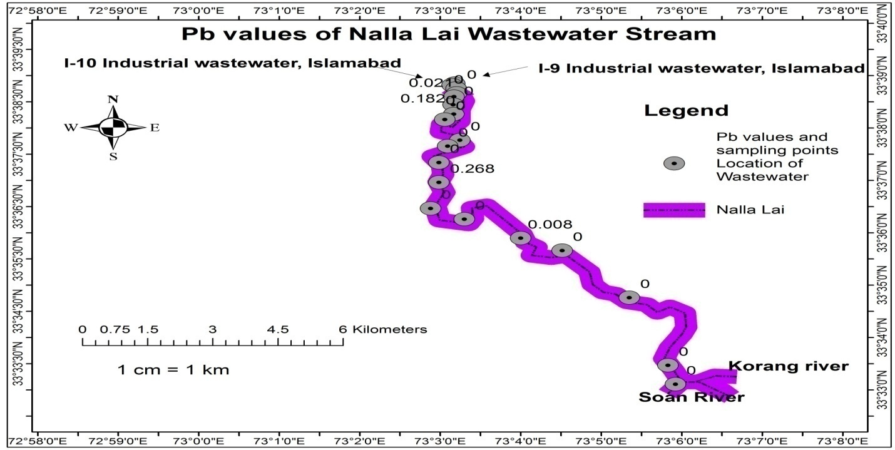

**Figure 14|** **Lead** values of wastewater along the Nalla Lai stream

**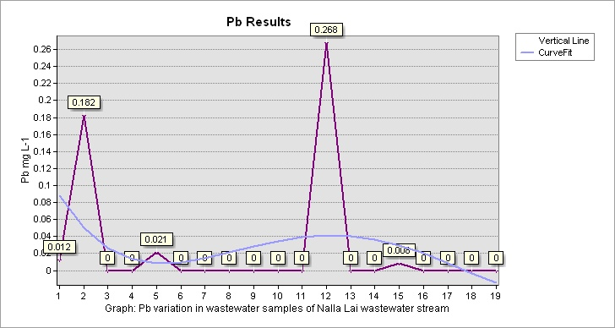**

**Graph 12|** **Lead** variation in wastewater samples of Nalla Lai stream

**3.13 Zinc**

Zinc is a metal that occurs in soil as Zn (II) rather than Zn (0) (Barak & Helmke 1993). Zinc concentration exists in rock types such as shale, limestone, sandstone, and igneous rocks (Hem 1972). The natural source of zinc in water is the erosion of soil that contains zinc particles. Anthropogenic sources of zinc in water include municipal and industrial wastes, urban runoff, and mine drainage (Noulas et al. 2018).

The National Environmental Quality Standards, 1997 (NEQs, 1997) value of zinc in wastewater is 5.0 mg L-1.

The average value of zinc in wastewater samples of Nalla Lai was 0.68 mg L-1. The maximum and minimum zinc values of wastewater samples were 4.20 mg L-1 and 0.05 mg L-1. Zinc values of all the analyzed wastewater samples along the Nalla Lai stream were within the range of NEQs, 1997. The results of zinc values in wastewater samples and descriptive statistical analysis results along with the set standards are mentioned in Table 1 and Table 2. Zinc values in each sampling point location along with the Nalla Lai wastewater stream are shown in Figure 15 of the ArcGIS map. The curve Fit line in Graph 13 shows that zinc is detected in low concentration in the initial wastewater samples that carry the discharges of industrial effluents of Islamabad as shown in Figure 2. The concentration of zinc in later wastewater samples was higher as compared to initial samples. It may indicate the presence of zinc concentration in wastewater streams discharging into Nalla Lai along its way at the confluence points of Rawalpindi as shown in Figure 2.

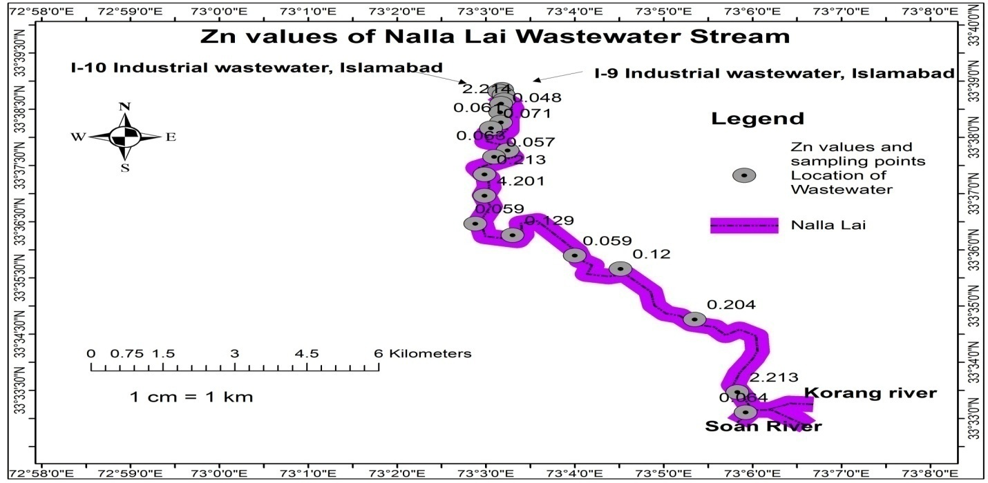

**Figure 15|** **Zinc** values of wastewater along the Nalla Lai stream

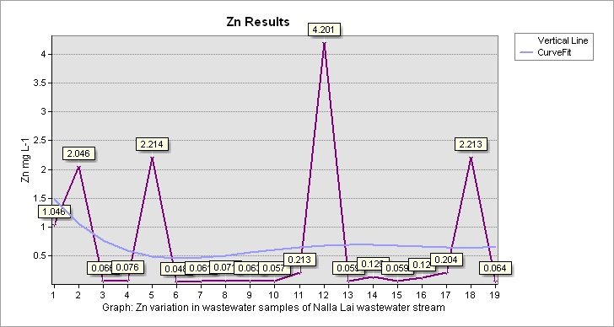

**Graph 13|** **Zinc** variation in wastewater samples of Nalla Lai stream

**3.14 Biological Oxygen Demand**

The increased organic matter in surface water from natural sources (decaying animal and plant wastes, feces, urine) and anthropogenic sources (detergents, oils, and grease) stimulates microbial decomposition that consumes dissolved oxygen (DO) in water. This utilization of DO in this case creates an oxygen depletion environment which do not support aquatic life such as fish. Biological oxygen demand (BOD) is defined as the microbial consumption of oxygen during the degradation of organic carbon (e.g. sugar: C6H12O6 ) in water. C6H12O6+O2 → 6CO2+6H2O

BOD5 measures the amount of dissolved oxygen utilized by microorganisms (aerobic bacteria) for 5 days at 20 ºC. It determines the strength of organic material in wastewater (Abdalla & Hammam 2014; Penn et al. 2009).

The National Environmental Quality Standards, 1997 (NEQs, 1997) value of biological oxygen demand in wastewater is 80 mg L-1. The average value of biological oxygen demand in wastewater samples of Nalla Lai was 120.21 mg L-1. The maximum and minimum biological oxygen demand values of wastewater samples were 194 and 87 mg L-1. Biological oxygen demand values of all the analyzed wastewater samples were beyond the standard limit value of NEQs, 1997. The results of BOD values in wastewater samples and descriptive statistical analysis results along with set standards are mentioned in Table 1 and Table 2. BOD values in each sampling point location along with the Nalla Lai wastewater stream are shown in Figure 16 of the ArcGIS map. The curve Fit line in Graph 14 shows the variation of BOD value along the Nalla Lai wastewater stream. The graph represents the elevated values of all wastewater samples along the Nalla Lai as compared to NEQs, 1997 standard. The results reveal the higher pollution load of organic compounds in the wastewater stream of Nalla Lai. BOD values of wastewater samples were comparatively elevated than the research results of Islam et al. (2016) when analyzing wastewater pollution and heavy metal determination of Kushtia industrial zone in Bangladesh.

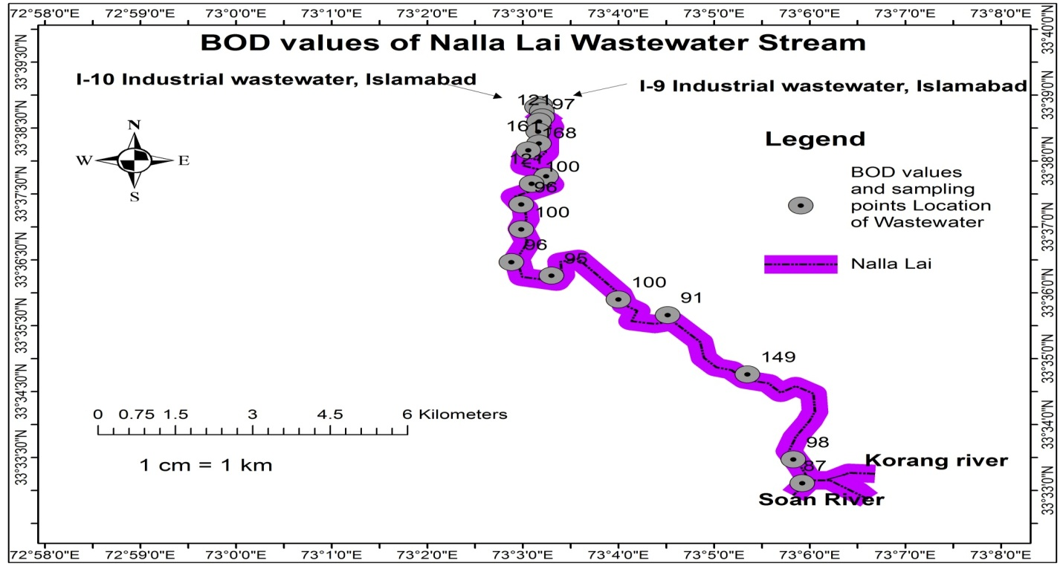

**Figure 16|** **Biological Oxygen Demand** values of wastewater along the Nalla Lai stream

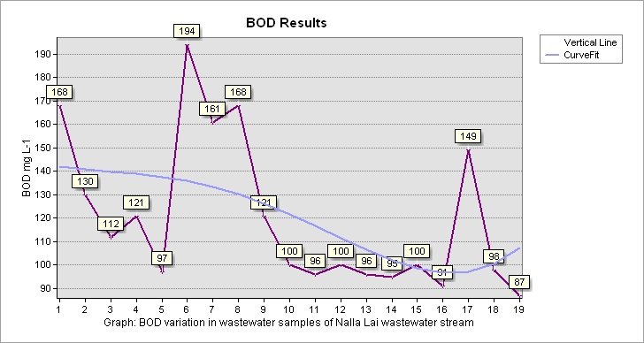

**Graph 14|** **Biological Oxygen Demand** variation in wastewater samples of Nalla Lai stream

**3.15 Chemical Oxygen Demand**

Chemical oxygen demand is the sum of total oxygen consumed during the decomposition and chemical oxidation of organic/inorganic material in wastewater by a strong oxidant (Sharma & Dahiya 2023). COD is a standard test for wastewater to consume oxygen in the form of potassium dichromate during the degradation of organic material and inorganic chemicals i.e. ammonia and nitrate for a few hours. COD is oxygen equivalents needed to oxidize organic matter in water. A strong oxidant is added to a water sample such as dichromate to digest the organic material and the remaining oxidant is found titrimetrically by using iron (II) sulfate or ferrous sulfate (FeSO4) as the titrant (Latif & Dickert 2014; Samudro & Mangkoedihardjo 2010).

The National Environmental Quality Standards, 1997 (NEQs, 1997) value of chemical oxygen demand in wastewater is 150 mg L-1. The average value of chemical oxygen demand in wastewater samples of Nalla Lai was 236.21 mg L-1. The maximum and minimum chemical oxygen demand values of wastewater samples were 315 mg L-1 and 168 mg L-1. Chemical oxygen demand values of all the analyzed wastewater samples were beyond the standard limit value of NEQs, 1997. The results of COD values in wastewater samples and descriptive statistical analysis results along with set standards are mentioned in Table 1 and Table 2. COD values in each sampling point location along with the Nalla Lai wastewater stream are shown in Figure 17 of the ArcGIS map. The curve Fit line in Graph 15 shows the variation of COD values along with Nalla Lai. The graph represents the elevated values of all wastewater samples along with Nalla Lai as compared to NEQs, 1997. The results reveal the higher pollution load of both organic and inorganic compounds in the wastewater stream of Nalla Lai. COD values of Nalla Lai wastewater samples were higher than the research results of Islam et al. (2016) when a study on the assessment of pollution levels in wastewater of the Kushtia industrial area of Bangladesh.

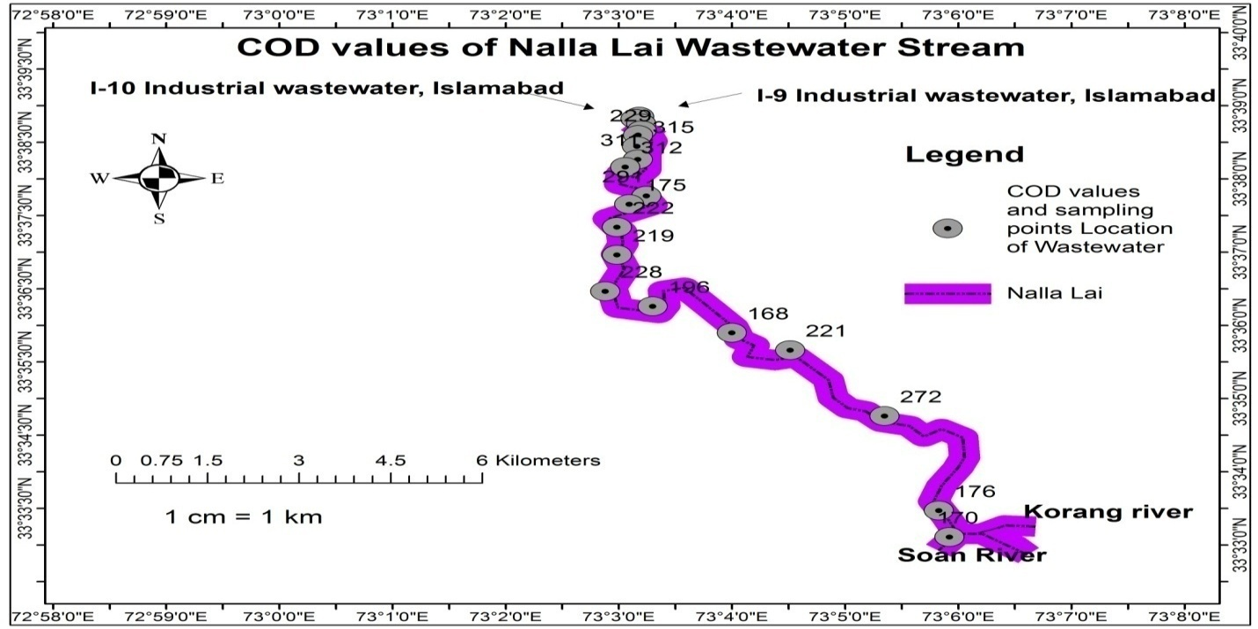

**Figure 17|** **Chemical Oxygen Demand** values of wastewater along the Nalla Lai stream

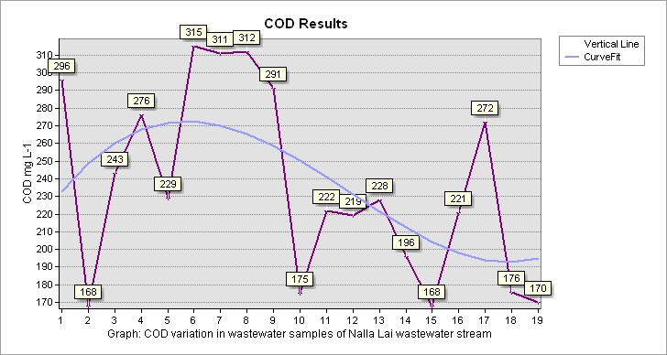

**Graph 15|** **Chemical Oxygen Demand** variation in wastewater samples of Nalla Lai stream

**3.16 Correlation**

Correlation is the reciprocal relationship between two variables. Correlation can be either positive or negative. When the two variables move in the same direction is called positive correlation whereas when the variables move in opposite direction is called negative correlation. The values of the correlation coefficient range from +1 to -1. The value 0 shows no linear correlation between the two variables. Strong, moderate and weak correlation ranges between +0.8 to +1.0, +0.5 to +0.8, and 0.0 to +0.5 respectively. The correlation coefficient of wastewater parameters is shown in Table 3 with blue, white, and red colors representing positive correlation, no correlation, and negative correlation among the analyzed wastewater parameters (Khan et al.2023).

**Table 3| Correlation Matrix** of Physicochemical Parameters of Wastewater of Study Area

|  |  |  |  |  |  |  |  |  |  |  |  |  |  |  |  |
| --- | --- | --- | --- | --- | --- | --- | --- | --- | --- | --- | --- | --- | --- | --- | --- |
|  | pH | Temperature | Turbidity | DO | EC | SO4 | Cl- | Cd | Cu | Fe | Mn | Pb | Zn | BOD | COD |
| pH | 1 |  |  |  |  |  |  |  |  |  |  |  |  |  |  |
| Temperature | 0.3194 | 1 |  |  |  |  |  |  |  |  |  |  |  |  |  |
| Turbidity | -0.0153 | -0.3133 | 1 |  |  |  |  |  |  |  |  |  |  |  |  |
| DO | 0.3576 | 0.0827 | 0.1139 | 1 |  |  |  |  |  |  |  |  |  |  |  |
| EC | 0.2514 | 0.0690 | -0.1421 | -0.0641 | 1 |  |  |  |  |  |  |  |  |  |  |
| SO4 | 0.4774 | 0.6005 | -0.0815 | 0.5197 | 0.2229 | 1 |  |  |  |  |  |  |  |  |  |
| Cl- | -0.0042 | -0.0157 | 0.4886 | 0.3063 | 0.0491 | 0.1975 | 1 |  |  |  |  |  |  |  |  |
| Cd | -0.3783 | -0.7825 | 0.1151 | -0.0821 | -0.5011 | -0.3622 | 0.1032 | 1 |  |  |  |  |  |  |  |
| Cu | -0.3599 | -0.5872 | 0.5680 | 0.0473 | -0.5233 | -0.3734 | -0.0067 | 0.5691 | 1 |  |  |  |  |  |  |
| Fe | -0.7011 | -0.7680 | 0.5372 | -0.1682 | -0.4154 | -0.5432 | 0.2164 | 0.5288 | 0.5106 | 1 |  |  |  |  |  |
| Mn | -0.1389 | -0.5982 | 0.5357 | 0.0325 | -0.2039 | -0.091 | -0.0395 | 0.508 | 0.623 | 0.6603 | 1 |  |  |  |  |
| Pb | 0.1020 | 0.4228 | -0.2001 | 0.1393 | -0.5609 | -0.3264 | -0.5115 | -0.3163 | -1 | -0.5064 | -0.4089 | 1 |  |  |  |
| Zn | -0.1836 | -0.1408 | -0.0816 | 0.1947 | -0.2504 | -0.2501 | -0.0033 | -0.0089 | -0.0046 | -0.0083 | -0.0763 | 0.836 | 1 |  |  |
| BOD | -0.0819 | -0.5698 | 0.3343 | -0.2794 | -0.0179 | -0.5679 | 0.1458 | 0.7363 | 0.3038 | 0.4404 | 0.1877 | -0.213 | -0.1768 | 1 |  |
| COD | -0.1092 | -0.4203 | 0.2504 | -0.5592 | 0.0543 | -0.5738 | 0.0297 | 0.3899 | 0.4362 | 0.3044 | 0.1581 | -0.279 | -0.2659 | 0.7935 | 1 |

$$\overline{4. CONCLUSIONS}$$

Based on the analyzed results of wastewater samples of Nalla Lai the study concluded that the discharges of industrial, commercial, institutional, and domestic effluents are heavily polluting the rainwater stream turned into a wastewater stream that cannot support any aquatic life. Dissolved oxygen level was detected as much lower than the NEQs, 1997 in many wastewater samples. BOD, COD, and Turbidity results in all wastewater samples were elevated from the recommended values of NEQs, 1997, and the standards of EPA Ghana. EC was higher than the standard value of EPA Ghana in two wastewater samples. Heavy metals like iron and cadmium were detected beyond the permissible limit value in many wastewater samples of the Nalla Lai stream. The experimental results of pH, Temperature, SO**42-**, Cl-, Cu, Mn, Pb, and Zn values of wastewater samples meet the acceptable standard limits of NEQs, 1997. The wastewater stream of Nalla Lai is about 17 Km in length in the Rawalpindi region and the wastewater cannot be used for any purpose and cannot be drained directly into any other surface water resource unless it is treated in the wastewater treatment plant. Unfortunately, the wastewater of Nalla Lai drains into the Soan River without passing through any treatment process that contaminates the Soan River, the Soan River directly drains into the Indus River which is a vital water resource for both drinking and irrigation purposes in both Punjab and Sindh provinces of Pakistan. Ultimately, the Indus River falls into the Arabian Sea near Karachi, Pakistan. Therefore, it is of prime importance to take concrete actions and necessary steps the responsible government organizations and international NGOs to cope with the issue by installing a wastewater treatment plant for the proper treatment of wastewater of Nalla Lai stream to minimize the detrimental impact of water pollution on human health, aquatic life and the overall quality of the environment.

**REFERENCES**

Abdalla, K. Z., & Hammam, G. (2014). Correlation between biochemical oxygen demand and chemical oxygen demand for various wastewater treatment plants in Egypt to obtain the biodegradability indices. International Journal of Sciences: Basic and Applied Research, 13(1), 42-48.

Ahmed, M. F., & Mokhtar, M. B. (2020). Assessing cadmium and chromium concentrations in drinking water to predict health risk in Malaysia. International Journal of Environmental Research and Public Health, 17(8), 2966. <https://doi.org/10.3390/ijerph17082966>

Amelot, D., Hassoun, A., Chamoreau, L. M., Amouri, H., & Moussa, J. (2018).Edelweiss Chemical Science Journal (ISSN 2641-7383).

APHA., AWWA., WEF., 2012 ‘Standard methods for the examination of water and wastewater’ 22th ed., American Public Health Association, American Water Works Association and Water Environment Federation., Washington, DC, USA.

Asghar, A., Ali, S. M., & Yasmin, A. 2012 Effect of climate change on apple (Malus domestica var. ambri) production: A case study in Kotli Satian, Rawalpindi, Pakistan. Pakistan Journal of Botany, 44(6), 1913-1918.

Atta, U., Hussain, M., & Malik, R. N. 2020 Environmental impact assessment of municipal solid waste management value chain: A case study from Pakistan. Waste Management & Research, 38(12), 1379-1388. <https://doi.org/10.1177/0734242X20942595>

Barak, P., & Helmke, P. A. (1993). The chemistry of zinc. In Zinc in Soils and Plants: Proceedings of the International Symposium on ‘Zinc in Soils and Plants’ held at The University of Western Australia, 27–28 September, 1993 (pp. 1-13). Springer Netherlands.

Benson, A. S., Dietrich, A. M., & Gallagher, D. L. (2012). Evaluation of iron release models for water distribution systems. Critical Reviews in Environmental Science and Technology, 42(1), 44-97. <https://doi.org/10.1080/10643389.2010.498753>

Bowell, R. J., Dill, S., Cowan, J., & Wood, A. (2004). A review of sulfate removal options for mine waters. Proceedings of mine water, 75-88.

Chang, H. (2008). Spatial analysis of water quality trends in the Han River basin, South Korea. Water research, 42(13), 3285-3304. <https://doi.org/10.1016/j.watres.2008.04.006>

Chusov, A. N., Bondarenko, E. A., & Andrianova, M. J. (2014). Study of electric conductivity of urban stream water polluted with municipal effluents. In Applied Mechanics and Materials (Vol. 641, pp. 1172-1175). Trans Tech Publications Ltd. DOI:[10.4028/www.scientific.net/AMM.641-642.1172](http://dx.doi.org/10.4028/www.scientific.net/AMM.641-642.1172" \t "_blank)

Colter, A., & Mahler, R. L. (2006). Iron in drinking water. Moscow: University of Idaho.

Das, A. P., Ghosh, S., Mohanty, S., & Sukla, L. B. (2014). Consequences of manganese compounds: a review. Toxicological & Environmental Chemistry, 96(7), 981-997. <https://doi.org/10.1080/02772248.2015.1005428>

Daughton, C. G.; Ternes, T. A. Environ. Health Perspect. 1999, 107 (Supplement 6), 907-938.

Dietrich, A. M., Glindemann, D., Pizarro, F., Gidi, V., Olivares, M., Araya, M., ... & Edwards, M. (2004). Health and aesthetic impacts of copper corrosion on drinking water. Water Science and Technology, 49(2), 55-62. <https://doi.org/10.2166/wst.2004.0087>

dos Santos, W. N., Costa, J. L., Araujo, R. G., de Jesus, D. S., & Costa, A. C. (2006). An on-line pre-concentration system for determination of cadmium in drinking water using FAAS. Journal of hazardous materials, 137(3), 1357-1361. <https://doi.org/10.1016/j.jhazmat.2006.03.046>

Fjallborg, B., & Dave, G. (2003). Toxicity of copper in sewage sludge. Environment international, 28(8), 761-769. <https://doi.org/10.1016/S0160-4120(02)00121-6>

G. Georgopoulos, A. Roy, MJ Yonone-Lioy, RE Opiekun, PJ Lioy, P. (2001). Environmental copper: its dynamics and human exposure issues. Journal of Toxicology and Environmental Health Part B: Critical Reviews, 4(4), 341-394. <https://doi.org/10.1080/109374001753146207>

Haider, H., & Ali, W. (2012). Diurnal variations in wastewater characteristics at Main Outfall in Lahore. Pakistan Journal of Engineering and Applied Sciences.

Hassan, M., Hassan, R., Mahmud, M. A., Pia, H. I., Hassan, M. A., & Uddin, M. J. (2017). Sewage waste water characteristics and its management in urban areas-A case study at pagla sewage treatment plant, dhaka. Urban and Regional Planning, 2(3), 13. doi: 10.11648/j.urp.20170203.11

Hem, J. D. (1972). Chemistry and occurrence of cadmium and zinc in surface water and groundwater. Water Resources Research, 8(3), 661-679. <https://doi.org/10.1029/WR008i003p00661>

Hu, J., Ma, Y., Zhang, L., Gan, F., & Ho, Y. S. (2010). A historical review and bibliometric analysis of research on lead in drinking water field from 1991 to 2007. Science of the total environment, 408(7), 1738-1744. <https://doi.org/10.1016/j.scitotenv.2009.12.038>

Islam, R., Al Foisal, J., Rahman, M., Lisa, L. A., & Paul, D. K. (2016). Pollution assessment and heavy metal determination by AAS in waste water collected from Kushtia industrial zone in Bangladesh. African Journal of Environmental Science and Technology, 10(1), 9-17. DOI: [10.5897/AJEST2014.1994](https://doi.org/10.5897/AJEST2014.1994)

Jeremias, J. M. (2010). Dissolved Oxygen and Biochemical Oxygen Demand in the waters close to the Quelimane sewage discharge. Acknowledgements, 10(2.1), 1504-9288.

Kamal, A. (2004). Pakistan: Lai Nullah Basin Flood Problem Islamabad Rawalpindi Cities. World Meteorological Organization/Global Water Partnership. Associated Programme on Flood Management, 1.

Kamberovic, Z. J. (2006). Characterization of wastewater streams from Bor site.

Kannel, P. R., Lee, S., Kanel, S. R., Khan, S. P., & Lee, Y. S. (2007). Spatial–temporal variation and comparative assessment of water qualities of urban river system: a case study of the river Bagmati (Nepal). Environmental Monitoring and Assessment, 129, 433-459.

Kara, C., & Comlekci, U. (2004). Journal of KSU, 7, 1.

Karmoker, J., Kumar, S., Pal, B. K., Sorowar, M. S., Rahman, M. A., Khan, M. H. R., & Islam, R. (2018). Characterization of wastewater from Jhenaidah municipality area, Bangladesh: A combined physico-chemical and statistical approach. AIMS Environmental Science, 5(6), 389-401. DOI: 10.3934/environsci.2018.6.389

Khan, A. A., Ashraf, M. I., Malik, S. U., Gulzar, S., & Amin, M. 2019 Spatial trends in surface runoff and influence of climatic and physiographic factors: A case study of watershed areas of Rawalpindi district. Soil & Environment, 38(2). DOI:10.25252/SE/19/81787

Khan, S. A., Rafiq, M. T., Shah, F. A., Aziz, R., Din, I., Yasir, A., & Iqbal, A. (2023). Evaluating the impact of Nalla

Lai contamination on drinking quality of groundwater in Rawalpindi city, Pakistan. Water Practice and

Technology, 18(2), 366-392.<https://doi.org/10.2166/wpt.2022.172>

Kumar, M., & Puri, A. (2012). A review of permissible limits of drinking water. Indian journal of occupational and environmental medicine, 16(1), 40. doi: [10.4103/0019-5278.99696](https://doi.org/10.4103%2F0019-5278.99696)

Ladwani Kiran, D., Ladwani Krishna, D., Manik Vivek, S., & Ramteke Dilip, S. (2012). Impact of industrial effluent discharge on physico-chemical characteristics of agricultural soil. International Research Journal of Environment Sciences, 1(3), 32-36.

Latif, U., & Dickert, F. L. (2014). Chemical oxygen demand. In Environmental Analysis by Electrochemical Sensors and Biosensors: Applications (pp. 719-728). New York, NY: Springer New York.

Levallois, P., Barn, P., Valcke, M., Gauvin, D., & Kosatsky, T. (2018). Public health consequences of lead in drinking water. Current environmental health reports, 5, 255-262.

Li, P., Qian, H., Howard, K. W., Wu, J., & Lyu, X. (2014). Anthropogenic pollution and variability of manganese in alluvial sediments of the Yellow River, Ningxia, northwest China. Environmental Monitoring and Assessment, 186, 1385-1398.

Ljung, K., & Vahter, M. (2007). Time to re-evaluate the guideline value for manganese in drinking water?. Environmental health perspectives, 115(11), 1533-1538. <https://doi.org/10.1289/ehp.10316>

Mandal, H. K. (2014). Influence of wastewater pH on turbidity. Int. J. Environ. Res. Dev, 4(2), 105-114.

Maqsood, A., Rashid, H., Khan, S. N., Nasir, A., Aman, N., Ullah, A. S., ... & Akbar, M. U. (2023). Wastewater

Characterization of Chiniot Drain and Evaluation of Groundwater Contamination Using Water Quality Index

(WQI) and GIS Techniques. *Pollutants*, *3*(1), 27-42.  <https://doi.org/10.3390/pollutants3010003>

Meybeck, M. (2002). Riverine quality at the Anthropocene: Propositions for global space and time analysis, illustrated by the Seine River. Aquatic Sciences, 64, 376-393.

Mohammed, S. S. (2015). Effect of pH on the Turbidity Removal of Wastewater. Open Access Library Journal, 2(12), 1. doi: [10.4236/oalib.1102283](http://dx.doi.org/10.4236/oalib.1102283).

Mohsin, M., Safdar, S., Asghar, F., & Jamal, F. (2013). Assessment of drinking water quality and its impact on residents health in Bahawalpur city. International Journal of Humanities and Social Science, 3(15), 114-128.

Mullins, D., Coburn, D., Hannon, L., Jones, E., Clifford, E., & Glavin, M. (2018). A novel image processing-based system for turbidity measurement in domestic and industrial wastewater. Water Science and Technology, 77(5), 1469-1482. <https://doi.org/10.2166/wst.2018.030>

Muttamara, S. (1996). Wastewater characteristics. Resources, conservation and recycling, 16(1-4), 145-159. <https://doi.org/10.1016/0921-3449(95)00052-6>

Nai, G. A., Golghetto, J. J., Estrella, M. P. S., Alves, J. A., & Garcia, L. A. (2015). pH dependence of cadmium-contaminated drinking water on the development of cardiovascular injury in Wistar rats. Biological Trace Element Research, 165, 81-85. DOI: [10.1007/s12011-014-0216-0](https://doi.org/10.1007/s12011-014-0216-0)

Noulas, C., Tziouvalekas, M., & Karyotis, T. (2018). Zinc in soils, water and food crops. Journal of Trace Elements in Medicine and Biology, 49, 252-260. <https://doi.org/10.1016/j.jtemb.2018.02.009>

Odjadjare, E. E., & Okoh, A. I. (2010). Physicochemical quality of an urban municipal wastewater effluent and its impact on the receiving environment. Environmental monitoring and assessment, 170(1-4), 383-394. DOI: [10.1007/s10661-009-1240-y](https://doi.org/10.1007/s10661-009-1240-y)

Owusu-Ansah, E. D. G. J., Sampson, A., Amponsah, S. K., Abaidoo, R. C., & Hald, T. (2015). Performance, compliance and reliability of waste stabilization pond: effluent discharge quality and environmental protection agency standards in Ghana. DOI:[10.19026/rjaset.10.1825](http://dx.doi.org/10.19026/rjaset.10.1825" \t "_blank)

Pal, S., & Chakraborty, K. (2017). Different aspects of chloride in freshwater: a review. International Journal of Current Trends in Science and Technology, 7(8), 20295-20303.

Patil, D. S., Chavan, S. M., & Oubagaranadin, J. U. K. (2016). A review of technologies for manganese removal from wastewaters. Journal of Environmental Chemical Engineering, 4(1), 468-487. DOI:[10.1016/j.jece.2015.11.028](http://dx.doi.org/10.1016/j.jece.2015.11.028" \t "_blank)

Paul, S. A., Chavan, S. K., & Khambe, S. D. (2012). Studies on characterization of textile industrial waste water in Solapur city. International Journal of Chemical Sciences, 10(2), 635-642.

Penn, M. R., Pauer, J. J., & Mihelcic, J. R. (2009). Biochemical oxygen demand. Environmental and ecological chemistry, 2, 278-297.

Pescod, M. B. (1992). Wastewater treatment and use in agriculture.

Prieto, F., Barrado, E., Vega, M., & Deban, L. (2001). Measurement of electrical conductivity of wastewater for fast determination of metal ion concentration. Russian Journal of Applied Chemistry, 74, 1321-1324. DOI:[10.1023/A:1013710413982](http://dx.doi.org/10.1023/A:1013710413982" \t "_blank)

Raashid, M., & Hussain, Z. 2014 Management of industrial effluent from paper and pulp industries using gravimetric circular clarifier technique. In Proceeding of 3rd International Conference on Environment, Chemistry and Biology (Vol. 78, pp. 11-14). DOI: 10.7763/IPCBEE. 2014. V78. 3

Remucal, C. K., & Ginder-Vogel, M. (2014). A critical review of the reactivity of manganese oxides with organic contaminants. Environmental Science: Processes & Impacts, 16(6), 1247-1266. DOI:[10.1039/c3em00703k](http://dx.doi.org/10.1039/c3em00703k" \t "_blank)

Rouf, M. A., Islam, M. S., Haq, M. Z., Ahmed, N., & Rabeya, T. (2013). Characterization of effluents of leather industries in Hazaribagh area of Dhaka city. Bangladesh Journal of Scientific and Industrial Research, 48(3), 155-166. DOI:[10.3329/bjsir.v48i3.17324](http://dx.doi.org/10.3329/bjsir.v48i3.17324" \t "_blank)

Samudro, G., & Mangkoedihardjo, S. (2010). REVIEW ON BOD, COD AND BOD/COD RATIO: A TRIANGLE ZONE FOR TOXIC, BIODEGRADABLE AND STABLE LEVELS. International Journal of Academic Research, 2(4).

Sarin, P., Snoeyink, V. L., Bebee, J., Jim, K. K., Beckett, M. A., Kriven, W. M., & Clement, J. A. (2004). Iron release from corroded iron pipes in drinking water distribution systems: effect of dissolved oxygen. Water research, 38(5), 1259-1269. DOI: [10.1016/j.watres.2003.11.022](https://doi.org/10.1016/j.watres.2003.11.022)

Sarkar, A., & Shekhar, S. (2018). Iron contamination in the waters of Upper Yamuna basin. Groundwater for Sustainable Development, 7, 421-429. DOI:[10.1016/j.gsd.2017.12.011](http://dx.doi.org/10.1016/j.gsd.2017.12.011" \t "_blank)

Shahid, I., Chishtie, F., Bulbul, G., Shahid, M. Z., Shafique, S., & Lodhi, A. 2019 State of air quality in twin cities of Pakistan: Islamabad and Rawalpindi. Atmósfera, 32(1), 71-84.  <https://doi.org/10.20937/atm.2019.32.01.06>.

Shaktibala, T., & Bhagat, S. K. (2012). Characterization of Waste Water of Industrial area of Sitapura, Jaipur for Post Monsoon Season 2012. Int. J. Sci. Res. Rev, 2, 227-235.

Sharma, A., & Dahiya, P. (2023). Characterization of wastewater and effluents remediation through nanotechnology for efficient reclamation and reuse. Emerging Technologies in Applied and Environmental Microbiology, 65-83. DOI:[10.1016/B978-0-323-99895-6.00009-5](http://dx.doi.org/10.1016/B978-0-323-99895-6.00009-5" \t "_blank)

Shrivastava, A. K. (2009). A review on copper pollution and its removal from water bodies by pollution control technologies. Indian Journal of Environmental Protection, 29(6), 552-560.

Sohail, M. T., Mahfooz, Y., Aftab, R., Yen, Y., Talib, M. A., & Rasool, A. (2020). Water quality and health risk of public drinking water sources: a study of filtration plants installed in Rawalpindi and Islamabad, Pakistan. Desalination Water Treat, *181*, 239-250. DOI:[10.5004/dwt.2020.25119](http://dx.doi.org/10.5004/dwt.2020.25119" \t "_blank)

Study, C. (2004). PAKISTAN: LAI NULLAH BASIN FLOOD PROBLEM ISLAMABAD–RAWALPINDI CITIES.

Sulieman, A. M. E. H., Yousif, A. W. M., & Mustafa, A. M. (2010). Chemical, physicochemical and physical properties of wastewater from the Sudanese fermentation industry (SFI). In Fourteenth International Water Technology Conference (Vol. 14, pp. 305-315). Citeseer. DOI:[10.13140/2.1.2662.1442](http://dx.doi.org/10.13140/2.1.2662.1442" \t "_blank)

Tai, H., Yang, Y., Liu, S., & Li, D. (2012). A review of measurement methods of dissolved oxygen in water. In Computer and Computing Technologies in Agriculture V: 5th IFIP TC 5/SIG 5.1 Conference, CCTA 2011, Beijing, China, October 29-31, 2011, Proceedings, Part II 5 (pp. 569-576). Springer Berlin Heidelberg. DOI:[10.1007/978-3-642-27278-3\_58](http://dx.doi.org/10.1007/978-3-642-27278-3_58" \t "_blank)

UNESCO, Water for a Sustainable World, 2015. The United Nations World Water Development Report 2015, Published by UNESCO on behalf of UN-Water, Paris, France.

United Nations Educational, Scientific and Cultural Organization (UNESCO). The United Nations World Water Development Report 4: Managing Water under Uncertainty and Risk. Paris. 2012，Available at: <http://unesdoc.unesco.org/images/0021/002156/215644e.pdf>.

Valipour, M. (2015). A comprehensive study on irrigation management in Asia and Oceania. Archives of Agronomy and Soil Science, 61(9), 1247-1271. DOI:[10.1080/03650340.2014.986471](http://dx.doi.org/10.1080/03650340.2014.986471" \t "_blank)

Venkatesan, G., & Swaminathan, G. (2009). Review of chloride and sulphate attenuation in ground water nearby solid‐waste landfill sites. Journal of environmental engineering and landscape management, 17(1), 1-7. DOI:[10.3846/1648-6897.2009.17.la-lg](http://dx.doi.org/10.3846/1648-6897.2009.17.la-lg" \t "_blank)

Wang, H., & Zhang, Q. (2019). Research advances in identifying sulfate contamination sources of water environment by using stable isotopes. International journal of environmental research and public health, 16(11), 1914. DOI:[10.3390/ijerph16111914](http://dx.doi.org/10.3390/ijerph16111914" \t "_blank)

Werkneh, A. A., Medhanit, B. Z., Abay, A. K., & Damte, J. Y. (2015). Physico-chemical analysis of drinking water quality at Jigjiga City, Ethiopia. American Journal of Environmental Protection, 4(1), 29-32. doi: 10.11648/j.ajep.20150401.14

Wetzel, R. G., & Likens, G. (2000). Limnological analyses. Springer Science & Business Media.

World Health Organization. (2003). Lead in drinking-water: background document for development of WHO guidelines for drinking-water quality (No. WHO/SDE/WSH/03.04/09). World Health Organization.

World Health Organization. (2004). Cadmium in drinking-water: background document for development of WHO guidelines for drinking-water quality (No. WHO/SDE/WSH/03.04/80). World Health Organization.

Zhang, R., Wilson, V. L., Hou, A., & Meng, G. (2015). Source of lead pollution, its influence on public health and the countermeasures. International Journal of Health, Animal Science and Food Safety, 2(1). <https://doi.org/10.13130/2283-3927/4785>